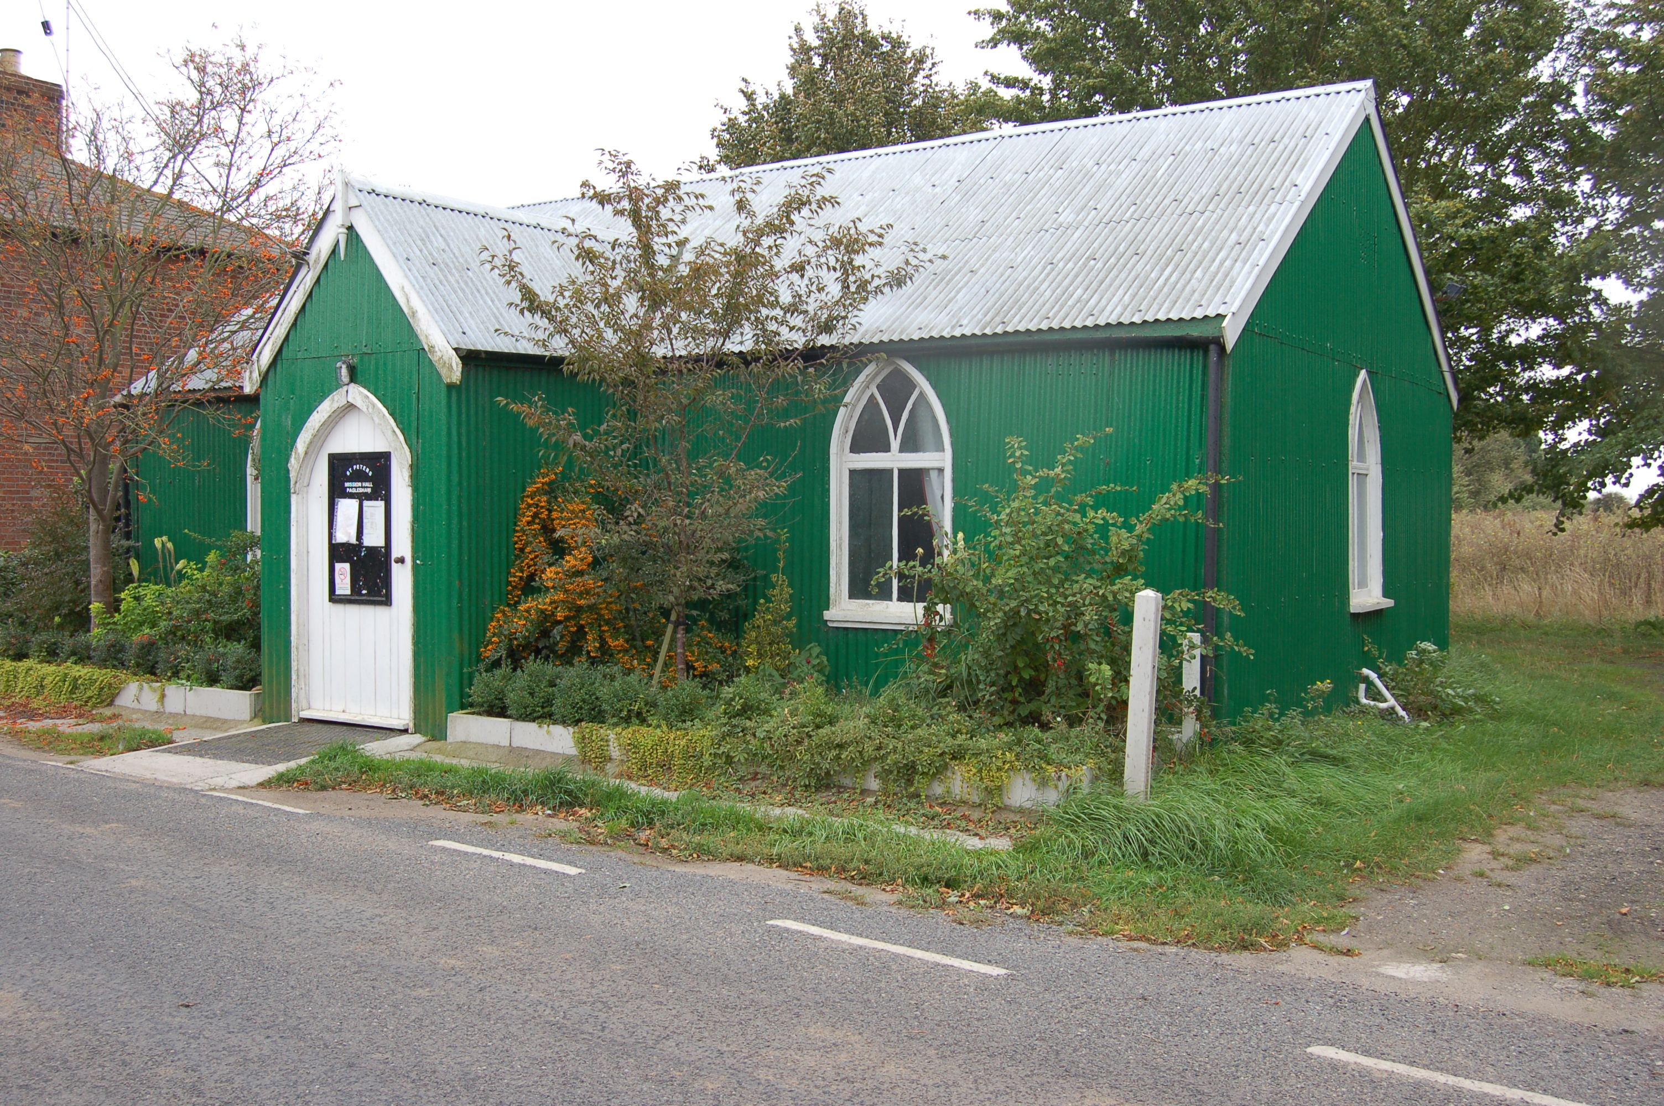

Would you like to place an advertisement in this magazine?

If you have any items for sale and you would like to advertise them in this magazine – there will be a charge of £1 per item.

If you have an item of news you feel is relevant and would like included in the magazine, please contact Val – 258616 or Angela – 258446,

PAGLESHAM

VILLAGE MAGAZINE

February 2018

PVPA (Paglesham Village Produce Association)
PVPA e-mail address – Anyone who would like to contact the PVPA please use the following e-mail address: pvpa.paglesham@gmail.com

Dates for your diary for 2018 :

24 March Litter pick-up 9.30 am at the Mission Hall.
Lunch at the Plough and Sail.

4 April Flower arrangement practice
7.30 pm at the Mission Hall

7 April Spring Show 2 – 3 pm Mission Hall

1 July Summer Picnic 1 pm at Mission Hall

25 August Summer Show

ST PETER’S CHURCH SERVICES

Tea, coffee and biscuits are served after each service.

Services: 2018

Services for February will be held in the Mission Hall

4 February 9.30 am Morning Prayer
18 February 9.30 am Holy Communion

Services for March onwards will be back at St Peter’s Church

4 March 9.30 am Morning Prayer
18 March 9.30 am Holy Communion

1 April EASTER SUNDAY 9.30 am Morning Prayer
15 April 9.30 am Holy Communion

6 May No service at Paglesham. All invited to
Stambridge Church at 11 am.

All other services will maintain the 1st and 3rd Sunday pattern unless otherwise stated on the Notice Board.

All services at St Peter’s are displayed on the Notice Board outside the Church.

Church Warden: Jeanette Birt – 01702 258607

PAGLESHAM WOMEN’S INSTITUTE meet the first Wednesday of the month at 2.30 pm in the Mission Hall. New members welcome. Why not come along for a taster session?

Ann Choppin

PAGLESHAM CONGREGATIONAL CHURCH
(OPPOSITE THE OLD SCHOOL)

We welcome anyone to our meetings held on 2nd and 4th Sundays most months. We are supported by Rochford Congregational Church and our Ministers are Rev D P Saunders and Rev A P Leach.

Paglesham Parish Council

Your village councillors are:

Chairman: David Whittingham tel: 258616

Parish Clerk: Barry Summerfield tel 01702 549308
All Parish Council papers are available on
Request to the Clerk

Councillors: Val McVittie
Jeanette Wooding
Robbie Fance
Kevin Bench

Next Parish Council Meeting 8 February 2018 at 8 pm in the Mission Hall – everyone is welcome to come along!

Pot Holes? Contact Parish Clerk on 549308
Street Lighting outage – contact the Parish Clerk as above
Worried about flooding in Paglesham? Why not sign up to Floodline – Tel – 0845 988 1188

David Whittingham
Chairman

VILLAGE NOTICE BOARD

It is with sadness we report the death of Betty Turner. Many of you will remember her as Mr Maxwell Lewis’s housekeeper. She was a member of the PVPA committee and her and Ian provided excellent food for occasions such as ‘Bonfire Night ‘ and the Judges lunches at the Show. Her funeral is on Thursday 1 February at 1 pm at Southend Crematorium. Our thoughts are with the family.

Local Police – To report incidents – Community Police Team
0300 333 4444 extension 494105

Bernie Illy or Steve Thomas 07710 046161

VILLAGE MAGAZINE

Some of you may have noticed that apart from the December issue I have not produced magazines since last September. This was because many people admitted they did not read or refer to them and would still ask for dates of events in the village. As you can appreciate, time, effort and money is spent in producing this magazine and it seemed pointless if it was not being read.

I have now decided I will produce a magazine as and when there are issues to report – such as Spring Show, Summer Show etc.

Obviously if there is anyone else who would like to take on this task, please feel free to contact me.

Val Whittingham

www.pagleshamparishcouncil.co.uk

