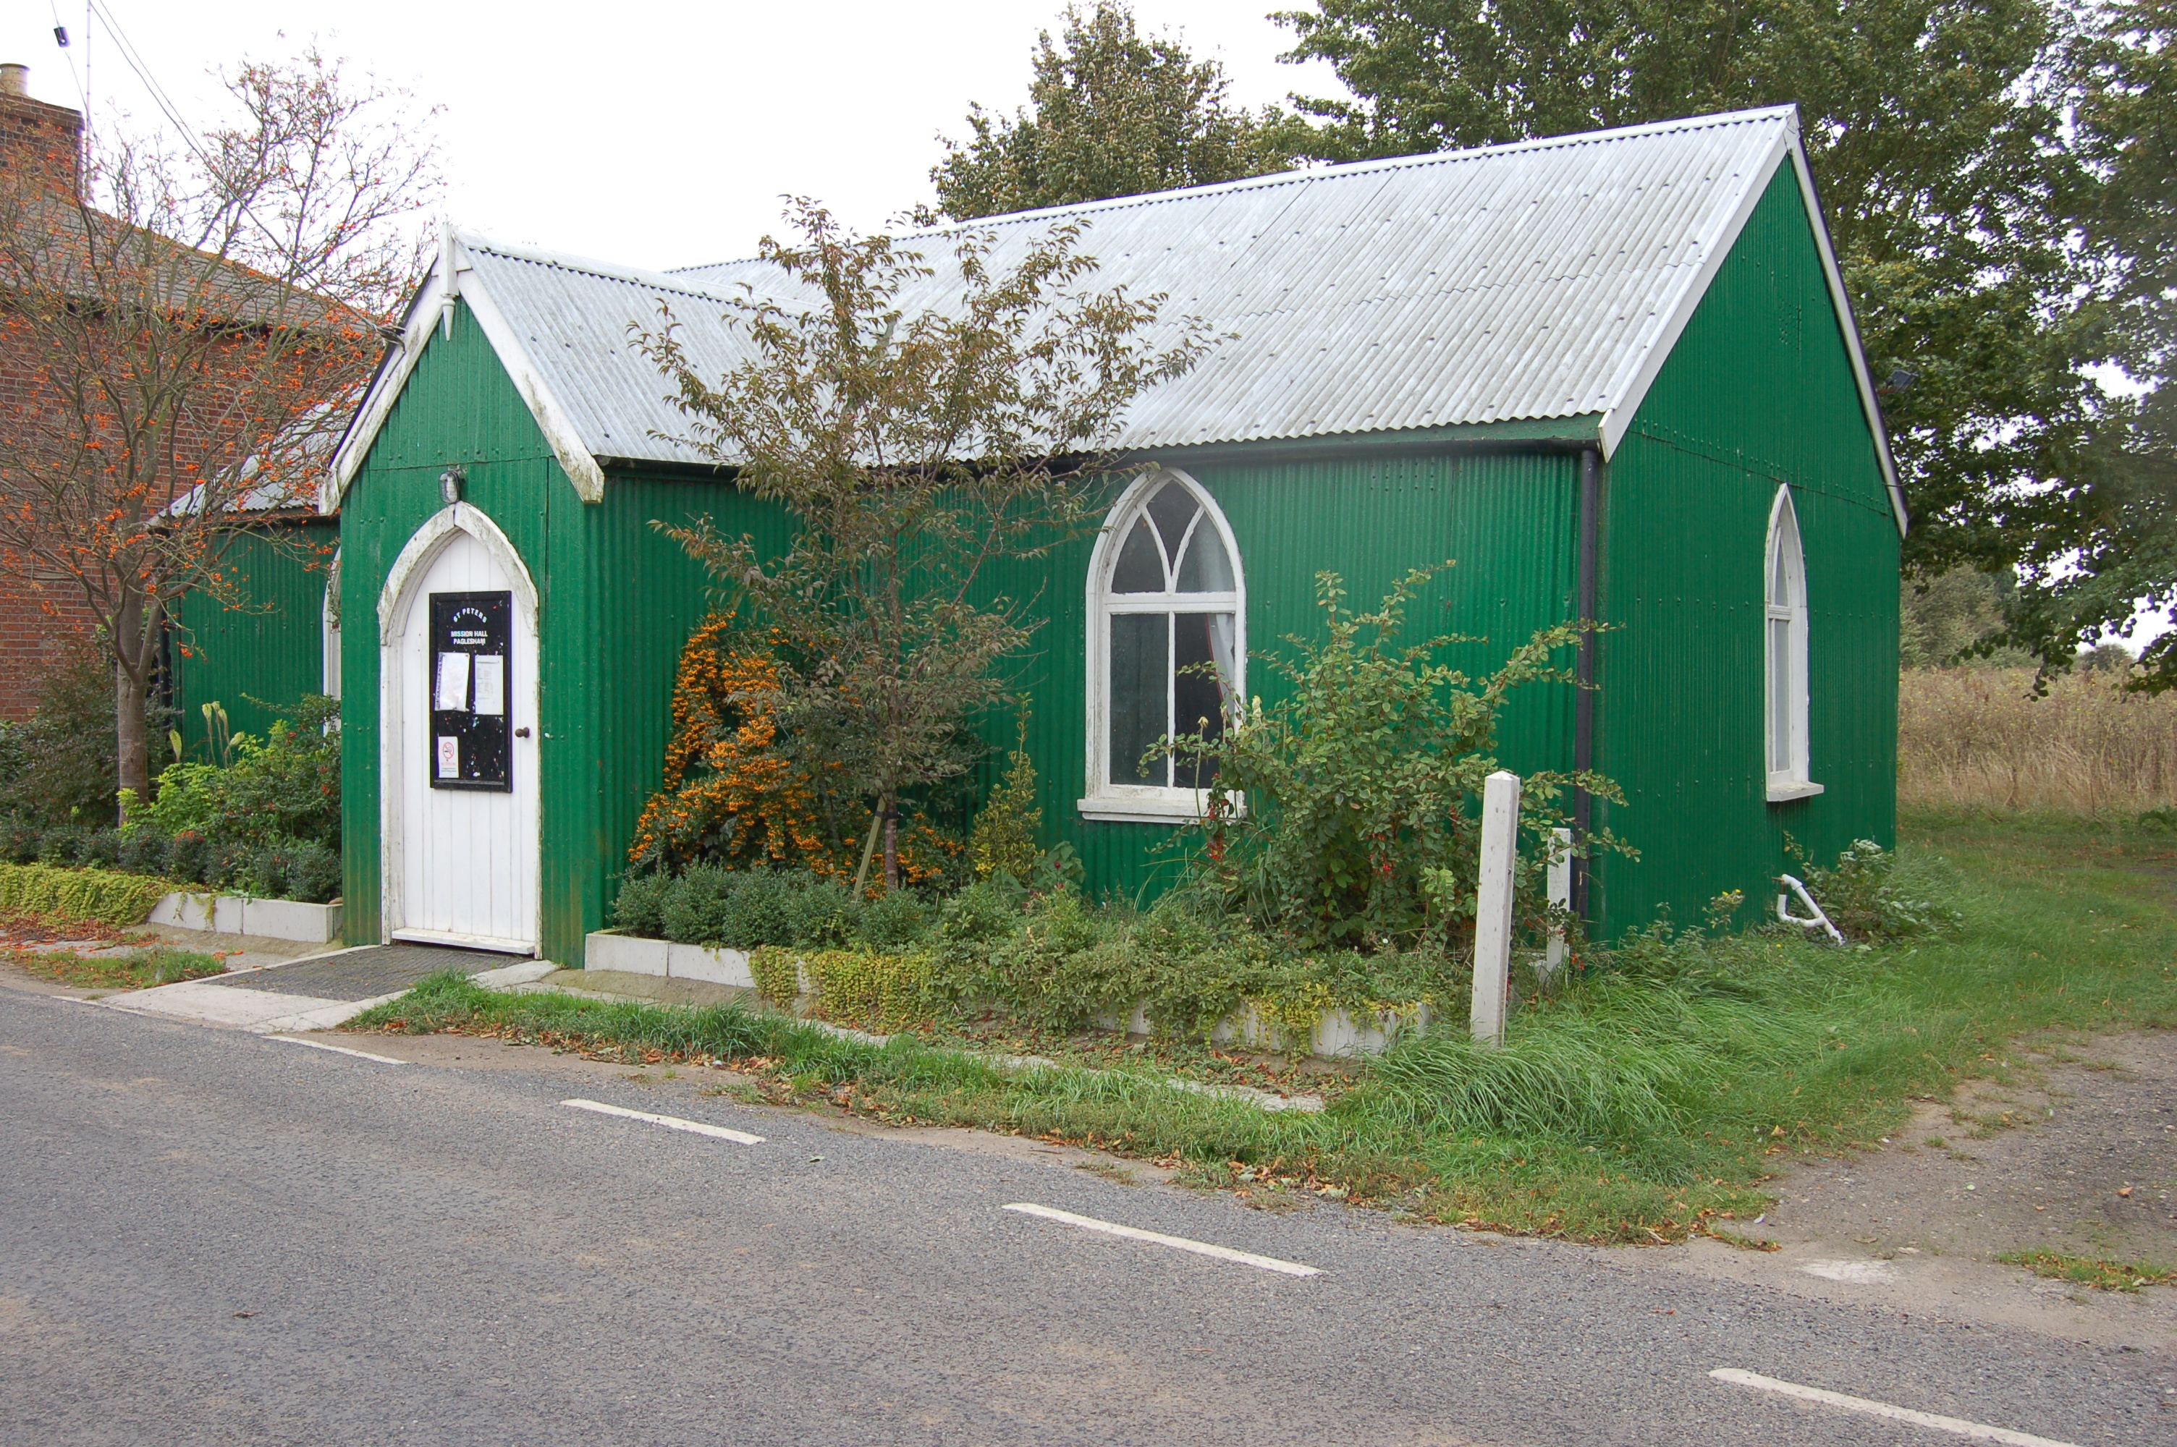

Would you like to place an advertisement in this magazine?

If you have any items for sale and you would like to advertise them in this magazine – there will be a charge of £1 per item.

If you have an item of news you feel is relevant and would like included in the magazine, please contact Val – 258616 or Angela – 258446 regarding any of the above by the 14 September ready for the October/November 2017 issue.

PAGLESHAM

VILLAGE MAGAZINE

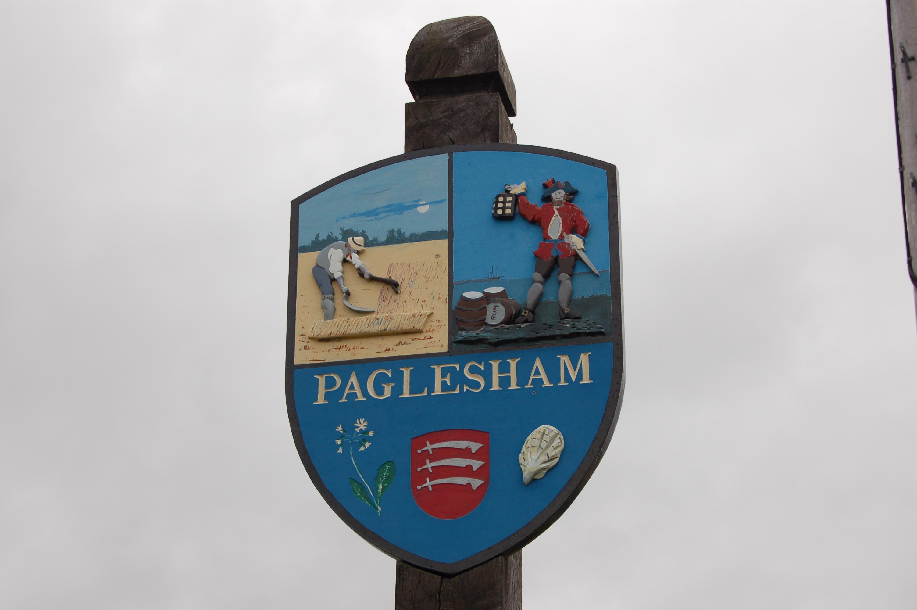

August/September 2017

PVPA (Paglesham Village Produce Association)
PVPA e-mail address – Anyone who would like to contact the PVPA please use the following e-mail address: pvpa.paglesham@gmail.com

Open Gardens

Thank you to everyone who opened their garden and helped on the day. Thank you also to all those who worked in the café and the car park. Without all the support this event could not happen. £1,365 was raised from Open Gardens and we hope this will go towards renovating the play equipment on the field.

Paglesham School Reunion

This was well attended and very much enjoyed by everyone. Thank you for all the help given on the day and before. We hope this will be an annual event probably interspersed with the Show.

Dates for your diary:

26 August - 71st Annual Summer Show if you would like to help in any way – please let a committee member
know
URGENT: Do you have any ideas for stalls or
for entertainment in the arena. If so please contact Mandy or Sue or any other committee member.

The marquee will be put up on Wednesday 23 August – around 5 pm. Please come and help
- refreshments will be provided.

Tea Tent Cakes needed for the tea tent and help on the day. If you can help please contact Angela or Val 258446 or 258616.

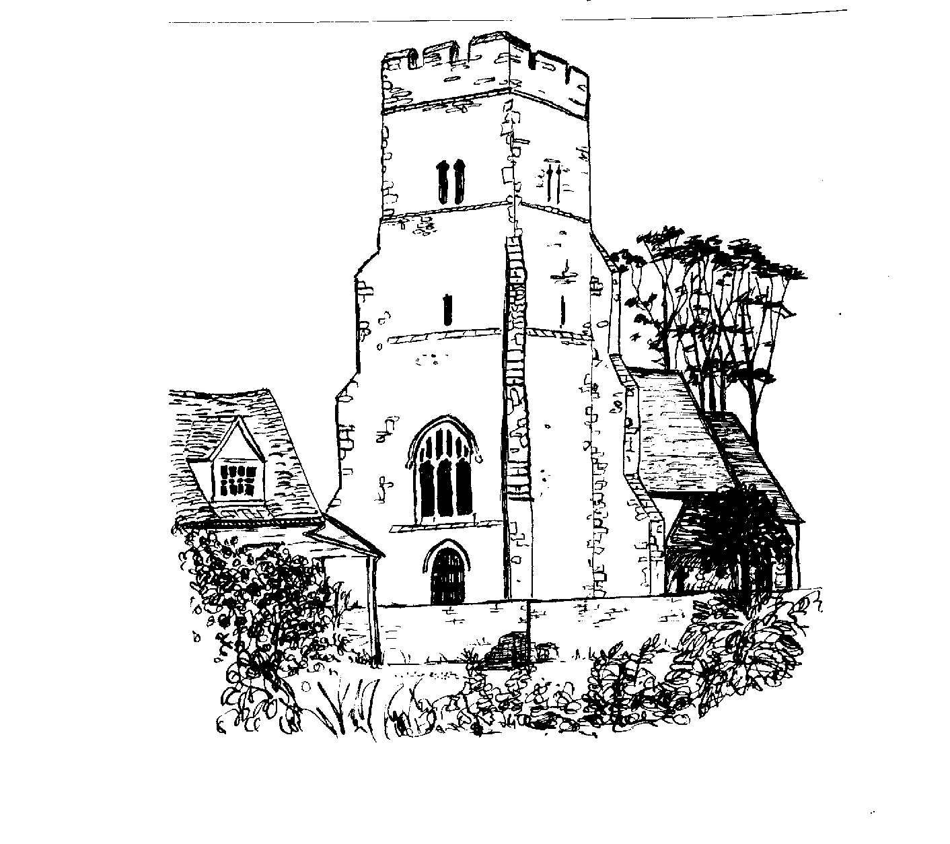

ST PETER’S CHURCH SERVICES

Tea, coffee and biscuits are served after each service.

Services:

6 August 9.30 am - Morning service with Gary Edwards
20 August 9.30 am – Holy Communion with Rev Elizabeth Jordan
3 September 9.30 am – Morning Service with Gary Edwards
20 September 9.30 am – Holy Communion with Rev Elizabeth Jordan

Flower Rota:

6 August Marian Barnard
20 August Janet Thorogood
3 September Barbara Chester
24 September Rhian Graves

All services at St Peter’s are displayed on the Notice Board outside the Church.

Church Warden: Jeanette Birt – 01702 258607

Harvest The date for this will be advertised on the Church notice Board

PAGLESHAM WOMEN’S INSTITUTE meet the first Wednesday of the month at 2.30 pm in the Mission Hall. New members welcome. Why not come along (free) for a taster session?

In June we visited an immaculately kept garden in Benfleet and afterwards enjoyed home made cake and tea. The owner specialised in heuchera and had introduced many interesting features.
July saw us entertaining 13 guests from surrounding WI’s. On a glorious day we were entertained with a talk on Three Queen Consorts, viz Alexandra, Mary and Elizabeth (the Queen Mother), and had afternoon tea under the gazebo behind the Mission Hall. This shelter afforded a necessary cool breeze both for us and the ample refreshments provided by Paglesham WI. One guest remarked that our catering would rival any afternoon tea offered at the Camilia Hotel on the sea front!

Ann Choppin

PAGLESHAM CONGREGATIONAL CHURCH
(OPPOSITE THE OLD SCHOOL)

We welcome anyone to our meetings held on 2nd and 4th Sundays most months. We are supported by Rochford Congregational Church and our Ministers are Rev D P Saunders and Rev A P Leach.

100 Club

Congratulations to the three winners of the June draw.

Val Whittingham
PCC Secretary to St Peter’s

Paglesham Parish Council

Your village councillors are:

Chairman: David Whittingham tel: 258616

Parish Clerk: Barry Summerfield tel 01702 549308
All Parish Council papers are available on
Request to the Clerk

Councillors: Val McVittie
Jeanette Wooding
Robbie Fance
Kevin Bench

Next Parish Council Meeting is on 7 September – at 8 pm in the Mission Hall – everyone is welcome to come along!

Pot Holes? Contact Parish Clerk on 549308
Street Lighting outage – contact the Parish Clerk as above
Worried about flooding in Paglesham? Why not sign up to Floodline – Tel – 0845 988 1188

David Whittingham
Chairman

YOUR MAGAZINE

Hopefully those wishing to access the Village Magazine have found it on the Paglesham Parish Council website.

www.pagleshamparishcouncil.co.uk - and follow the links to the magazine.

If you are still having a printed version but are able to access the Internet to view the magazine, please let me know as this will reduce my printing costs.

Val Whittingham

VILLAGE NOTICE BOARD

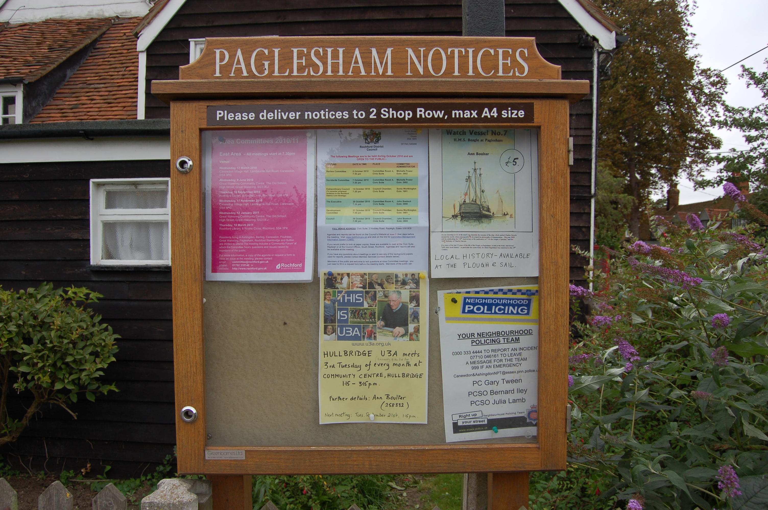

Local Police – To report incidents – Community Police Team
0300 333 4444 extension 494105

Bernie Illy or Steve Thomas 07710 046161

Frances Field was recently rented out for a wedding. Notice was given to residents living near the field to inform them there may be some noise from the music but it would cease by midnight. By renting out our field it is a valuable source of income to help maintain the field, the toilets and the general upkeep. The field is a resource for all of the village to use and we hope the small amount of inconvenience will not deter people from using it.

