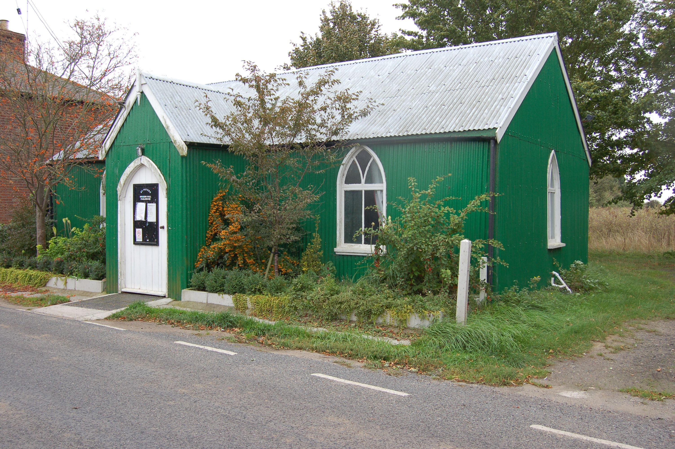

Would you like to place an advertisement in this magazine?

If you have any items for sale and you would like to advertise them in this magazine – there will be a charge of £1 per item.

If you have an item of news you feel is relevant and would like included in the magazine, please contact Val – 258616 or Angela – 258446 regarding any of the above by the 14 July ready for the August/September 2017 issue.

PAGLESHAM

VILLAGE MAGAZINE

June / July 2017

PVPA (Paglesham Village Produce Association)
PVPA e-mail address – Anyone who would like to contact the PVPA please use the following e-mail address: pvpa.paglesham@gmail.com

Spring Show – 1 April 2017

Thank you to everyone who supported the Show with their entries and their help. It was a wonderful display. If you would like to be a part of the committee to support our village, please contact the PVPA by going to the above e-mail address. New members are needed in order to carry on with all the events organised during the year.

Dates for your diary:

25 June - Open gardens – Please contact a member of the
committee if you are able to open your garden - Mandy Turner 258769 or Sue Winter 257251 or mobile 07780703952

9 July - 12 noon onwards Reunion of Paglesham
Village School
Invitations will be going out shortly but if you
know of anyone who used to go to the school
please let them know the date and let the
Committee have details. Alternatively send your replies to the post box that will be outside the Mission Hall. Bring your own picnic lunch
‘fizz and cake’ provided.

26 August - 71st Annual Summer Show if you would like to help in any way – please let a committee member
know
URGENT: Do you have any ideas for stalls or
for entertainment in the arena. If so please contact Mandy or Sue or any other committee member.

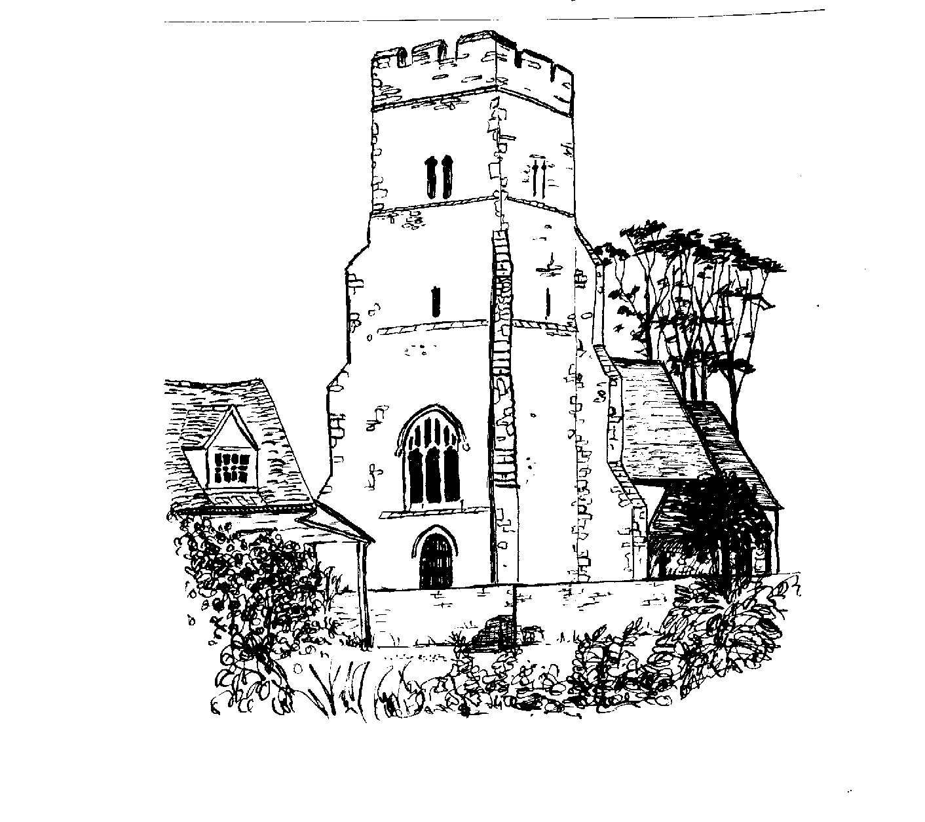

ST PETER’S CHURCH SERVICES

Tea, coffee and biscuits are served after each service.

Services:

4 June 9.30 am - Morning service with Gary Edwards
18 June 9.30 am – Holy Communion with Rev Elizabeth Jordan
2 July 9.30 am – Morning Service with Gary Edwards
16 July 9.30 am – Holy Communion with Rev Elizabeth Jordan

Flower Rota:

4 June Jeanette Birt
18 June Lesley Wade
2 July Emma Rolph
16 July Mary Vince/Sarah Fulcher

All services at St Peter’s are displayed on the Notice Board outside the Church.

Church Warden: Jeanette Birt – 01702 258607

PAGLESHAM WOMEN’S INSTITUTE meet the first Wednesday of the month at 2.30 pm in the Mission Hall. New members welcome. Why not come along (free) for a taster session?

Ann Choppin

PAGLESHAM CONGREGATIONAL CHURCH
(OPPOSITE THE OLD SCHOOL)

We welcome anyone to our meetings held on 2nd and 4th Sundays most months. We are supported by Rochford Congregational Church and our Ministers are Rev D P Saunders and Rev A P Leach.

100 Club

For those new to the village this is a fundraising Club to help with the day to day running of St Peter’s Church. It costs £20 per person per year and there are two draws. The aim is for 100 members. The next draw will take place at the Open Gardens in the Café. It runs from June to June but if you would like to enter for this draw it is not too late but I will be collecting for the next year at the Open Gardens.

Val Whittingham
PCC Secretary to St Peter’s

Paglesham Parish Council

Your village councillors are:

Chairman: David Whittingham tel: 258616

Parish Clerk: Barry Summerfield tel 01702 549308
All Parish Council papers are available on
Request to the Clerk

Councillors: Val McVittie
Jeanette Wooding
Robbie Fance
Kevin Bench

Next Parish Council Meeting is on 6 July – at 8 pm in the Mission Hall – everyone is welcome to come along!

Pot Holes? Contact Parish Clerk on 549308
Street Lighting outage – contact the Parish Clerk as above
Worried about flooding in Paglesham? Why not sign up to Floodline – Tel – 0845 988 1188

David Whittingham
Chairman

YOUR MAGAZINE

Hopefully those wishing to access the Village Magazine have found it on the Paglesham Parish Council website.

www.pagleshamparishcouncil.co.uk

If you are still having a printed version but are able to access the Internet to view the magazine, please let me know as this will reduce my printing costs.

Val Whittingham

Village Clean Up

As you will be aware a group of people from the village did a really good clean up earlier in the year. It is very upsetting therefore to see our lovely village spoilt by someone ‘throwing’ their household rubbish in the roads throughout our village
If you know of anyone doing this please let us know. Angela and I regularly collect rubbish on our daily walk as I know do other conscientious people whom we thank.

VILLAGE NOTICE BOARD

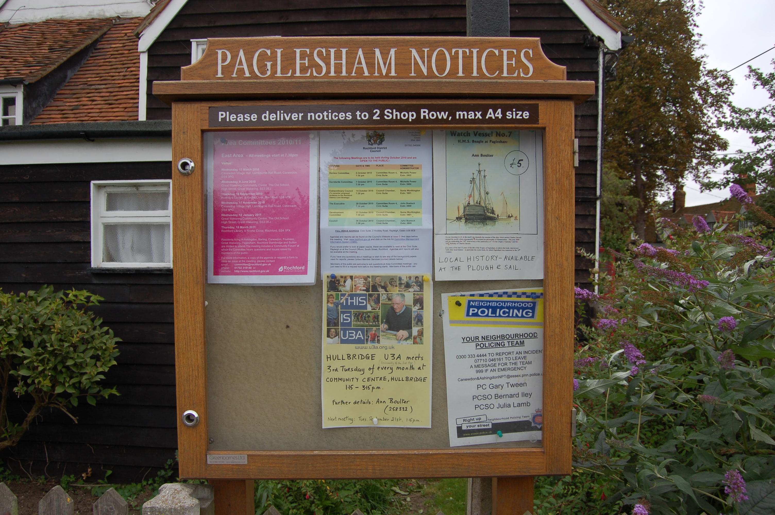

Local Police – To report incidents – Community Police Team
0300 333 4444 extension 494105

Bernie Illy or Steve Thomas 07710 046161

It was recently reported to me by a local resident that she had come across a lady with her daughter on Frances Field. The daughter has autism and our field is an oasis for her as she can run free and enjoy the play equipment and the pond without having to confront other children. It was a lovely compliment for our village.

