PAGLESHAM

VILLAGE MAGAZINE

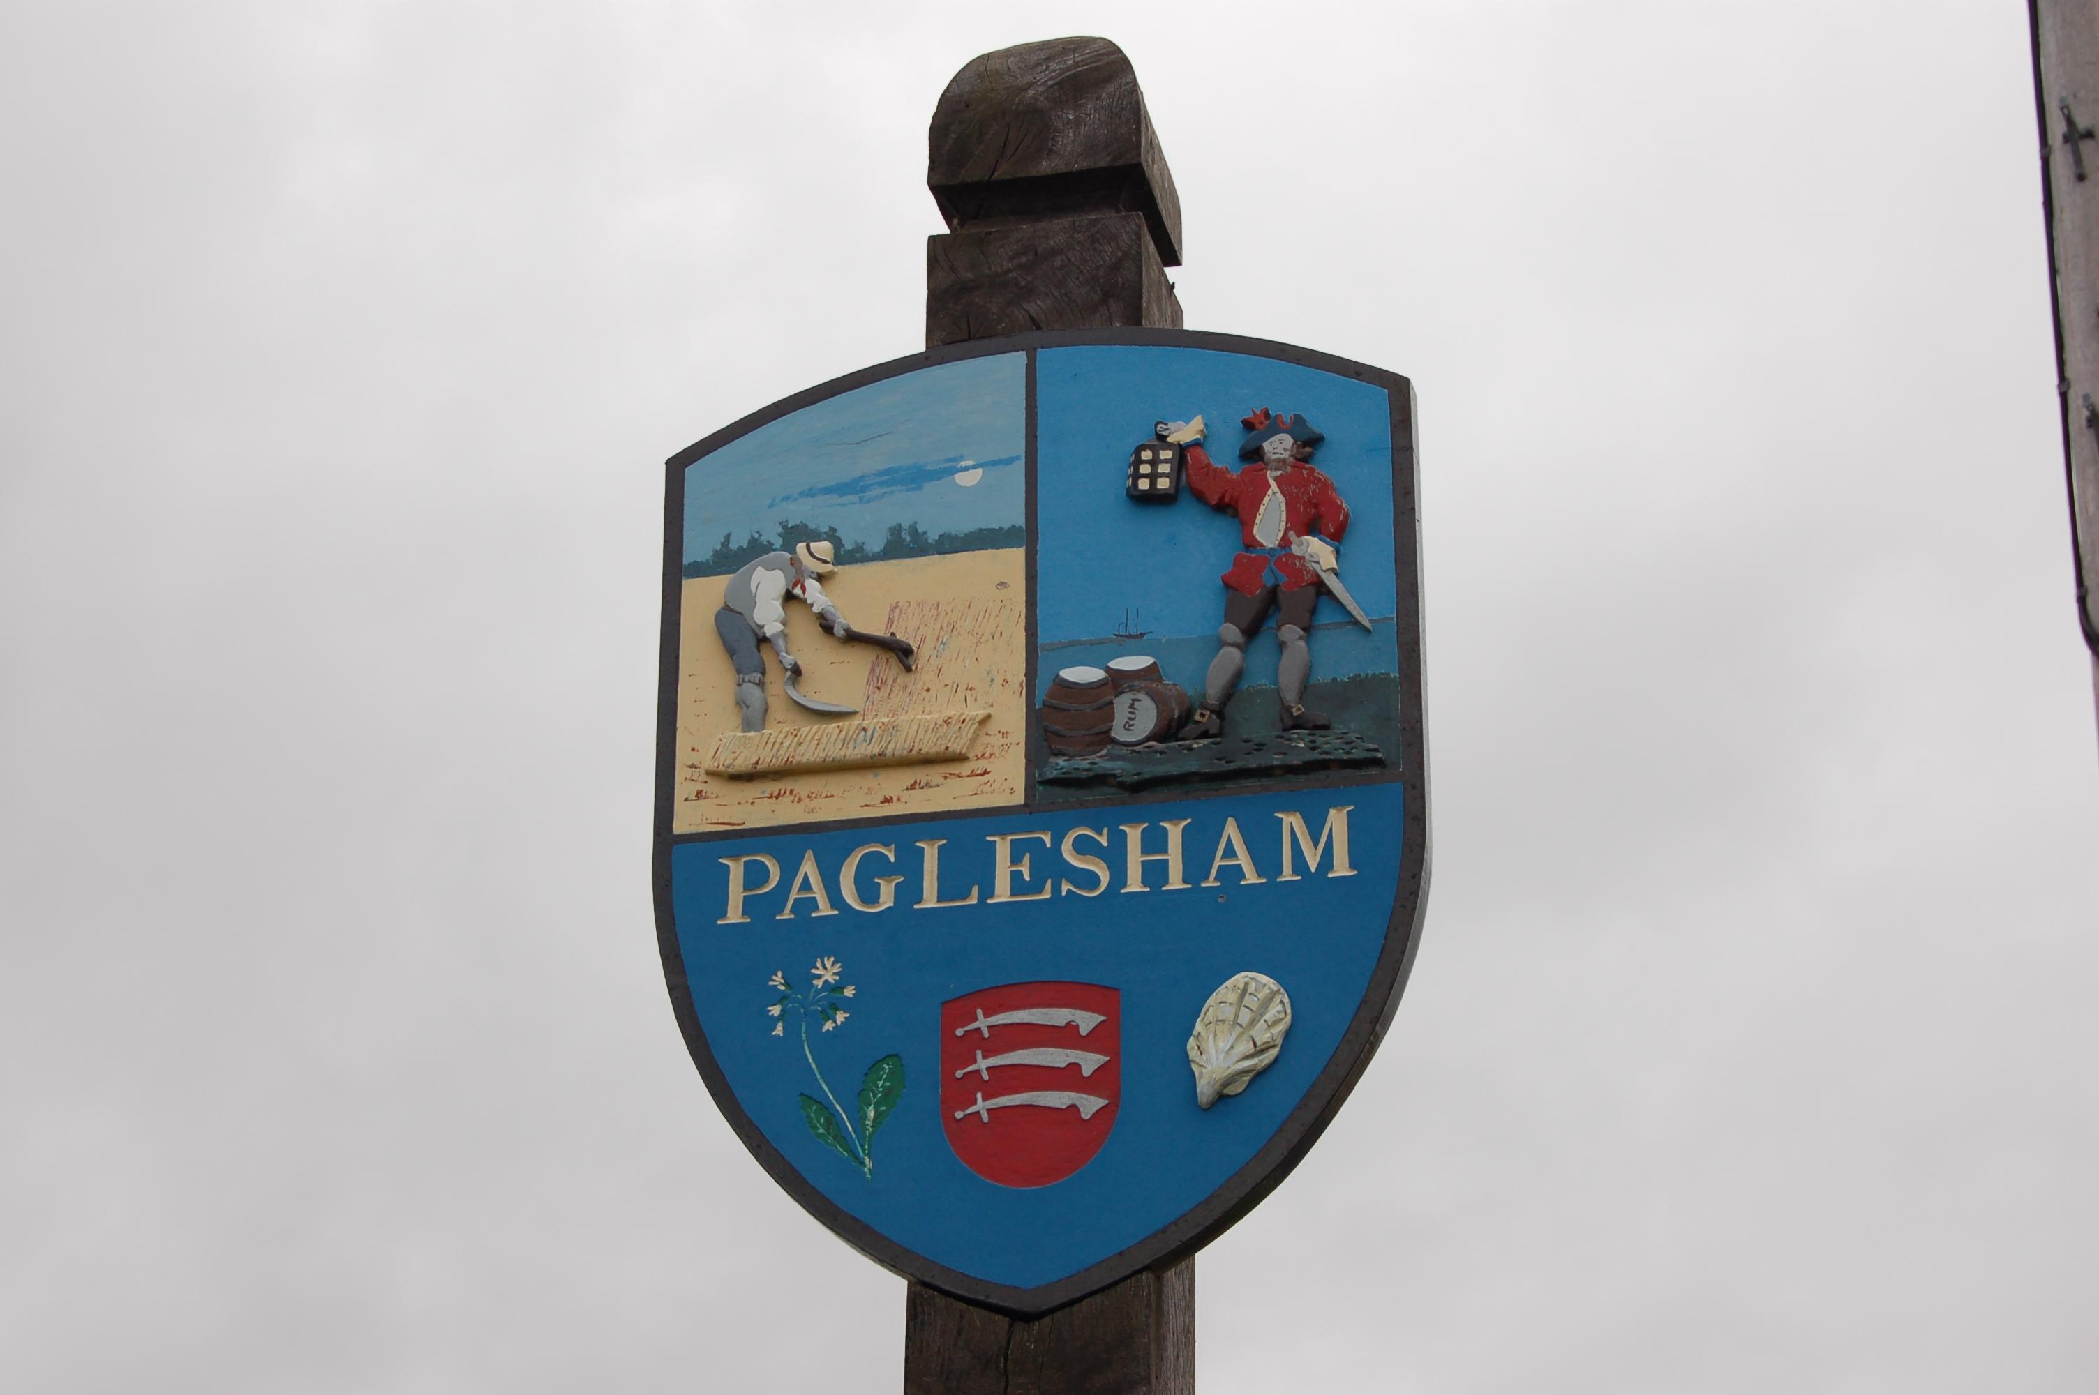

December 2017

PVPA (Paglesham Village Produce Association)
PVPA e-mail address – Anyone wlshing to contact the PVPA please use the following e-mail address: pvpa.paglesham@gmail.com

Dates for your Diary:

3 December Christmas tree lighting

With the Salvation Army – Mince Pies and Mulled Wine,

4.30 pm outside the Plough and Sail Public House

10 December – 12 midday - Senior Citizens Lunch

Winter supper at the Plough and Sail

7.30 for 8 pm 3 courses £17 per head

Main meal choices – Sausage and Mash, Chicken Currey or Vegetable stir fry

Please call 258446 to make your reservation

24 December – Carol Singing round village – Start at 6.30 pm at the village Christmas Tree opposite the Plough and Sail. If you would like us to call please let us know. Refreshments are great but not essential.

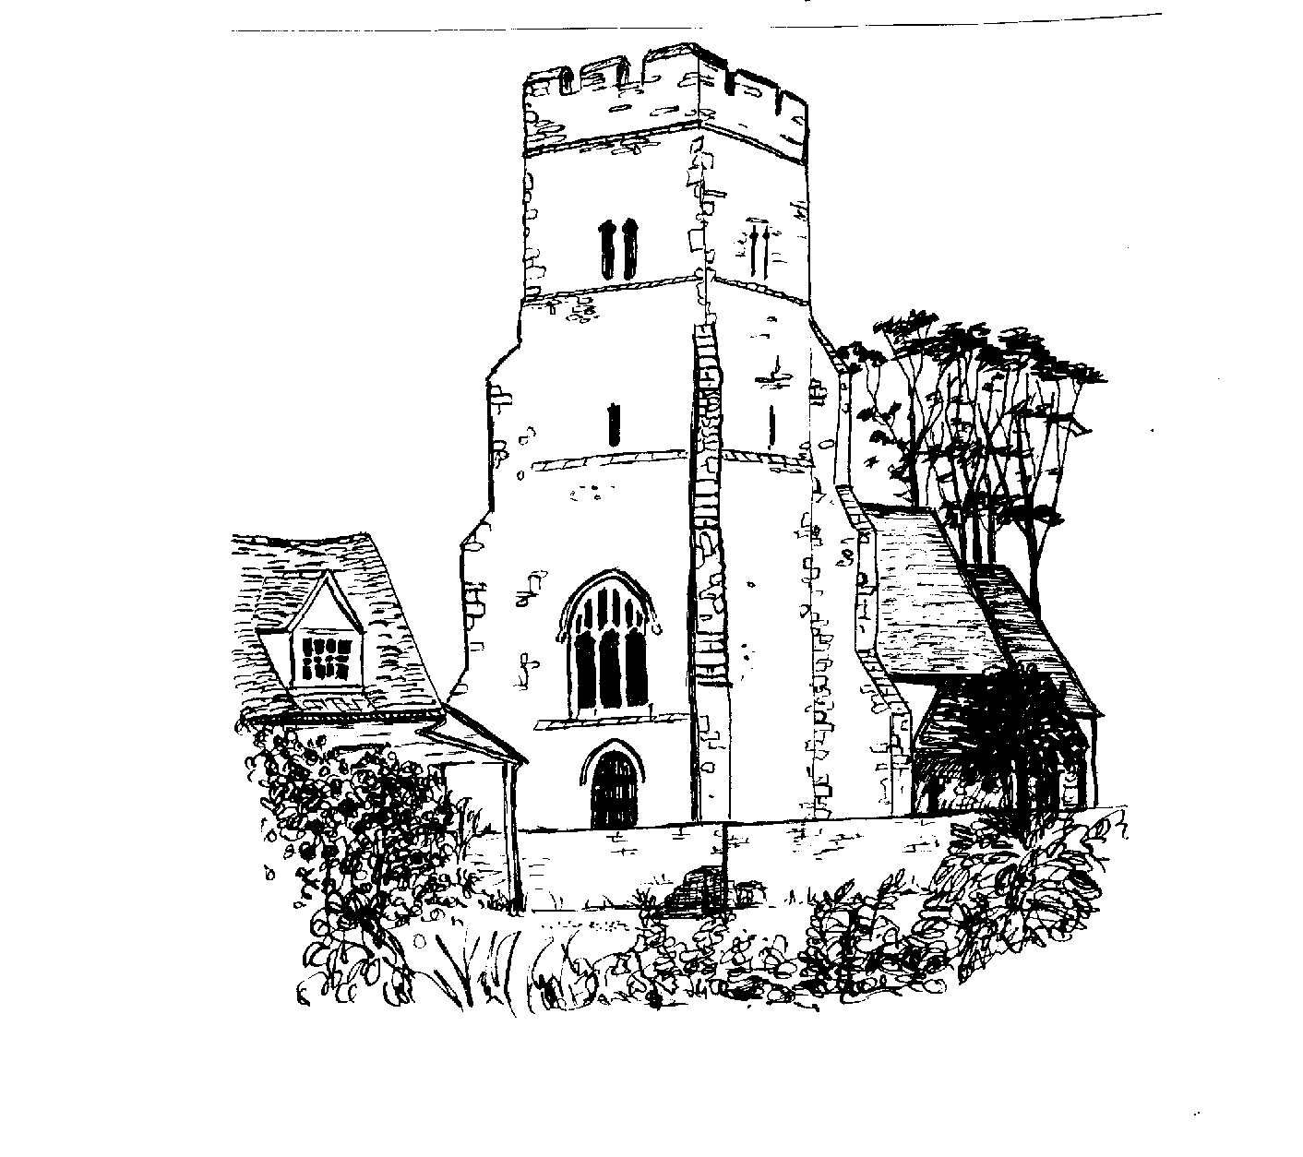

ST PETER’S CHURCH SERVICES

Tea, coffee and biscuits are served after each service.

Services:
3 December 9.30 am Morning Prayer
17 December 4 pm Carol Service and Christingle– all welcome
25 December 11.15 am Holy Communion

January 2018 services will be held in the Mission Hall

7January 9.30 am Morning Prayer
21 January 9.30 am Holy Communion

Flower Rota:

3 December Val Whittingham
16 December All helpers please to prepare for Christmas

No flowers required for January as services will be in Mission Hall.

All services at St Peter’s and Canewdon, Ashingdon and South Fambridge are displayed on the organ notice board in St Peters.

Clergy and Parish Officers

Church Warden: Jeanette Birt – 01702 258607

PAGLESHAM WOMEN’S INSTITUTE meet the first Wednesday of the month at 2.30 pm in the Mission Hall. New members welcome. Why not come along for a taster session?

PAGLESHAM CONGREGATIONAL CHURCH
(OPPOSITE THE OLD SCHOOL)

We welcome anyone to our meetings held on 2nd and 4th Sundays most months. We are supported by Rochford Congregational Church and our Ministers are Rev D P Saunders and Rev A P Leach.

Paglesham Parish Council

Your village councillors are:

Chairman: David Whittingham tel: 258616
Parish Clerk: Barry Summerfield tel: 01702 549308
All Parish Council papers are available on
Request to the Clerk
Councillors: Val McVittie
Jeanette Wooding
Kevin Bench
Robbie Fance

Next Parish Council Meeting Thursday 14 December 2017 at 8 pm in the Mission Hall – everyone is welcome to come along!

Pot Holes? Contact Parish Clerk on 549308
Street Lighting outage – contact the Parish Clerk as above
Worried about flooding in Paglesham? Why not sign up to Floodline – Tel – 0845 988 1188

David Whittingham
Chairman

NOTICES FOR THE PAGLESHAM PARISH COUNCIL WEBSITE:

Anyone wishing to put notices on the website concerning village activities or societies please contact either Val or Angela – 258616 258446 We will then forward them to the Clerk for entry to the website.

Letter from the Editors:

You may or not have noticed that there was not a magazine for October/November. The reason for this was that after speaking with a few people we found that it was not actually read. Indeed we have not had one enquiry as to where or why it has not been produced. Obviously to create the magazine it takes time, effort and expense. It may be that a new way of communicating news to the village is needed. We decided to do this ‘one off’ for Christmas and include all the names we had last year to wish people in the village ‘a very happy Christimas’.

We will continue to put the relevant dates of events on to the Paglesham Parish Council website.

Regards

Angela and Val

www.pagleshamparishcouncil.co.uk

The following people would like to wish Paglesham Village residents a very Happy Christmas and a Healthy and Peaceful New Year.

Instead of sending cards they will donate to a charity of their choice.

Angela and Ian Puzey
Debbie and Peter Watson
Maureen Glanville
Barbara and Stephen Cane
Rhian and Simon Graves
John and Sue Whittingham
Maggie and Barry Summerfield
Wendy and Paul Masters
Val and David Whittingham
Barbara Quilliam
Barbara Chester
Beryl and Jamie Mason
Julie and Dave (The Lodge)
VILLAGE NOTICE BOARD

Local Police – To report incidents – Neighbourhood Police Team
0300 333 4444 extension 494105

Steve - 07801461653

