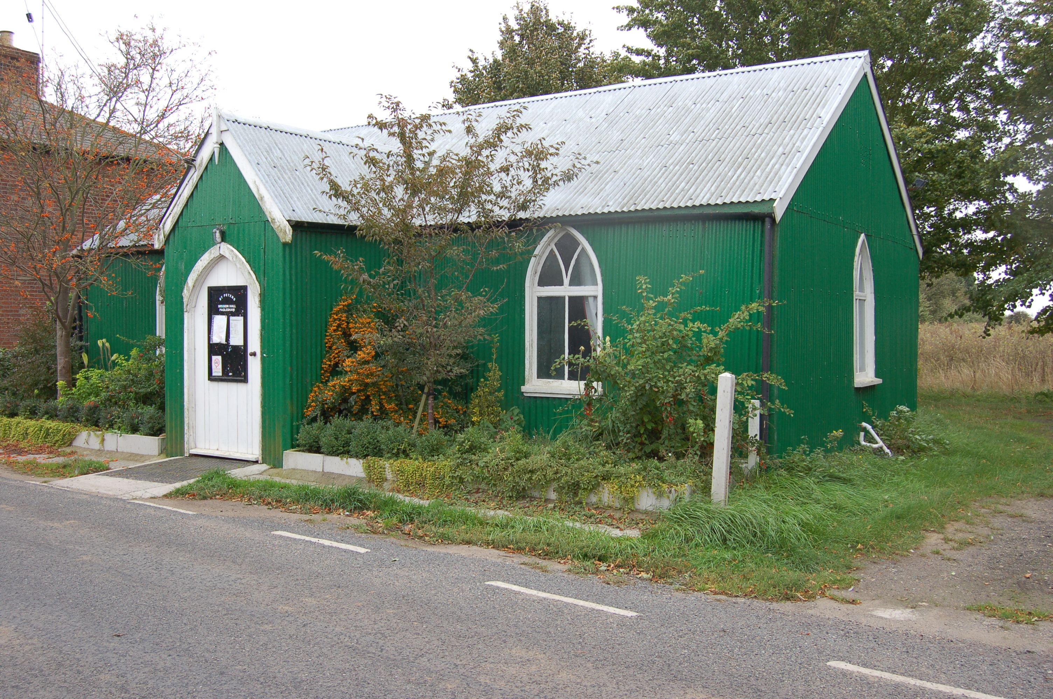

Would you like to place an advertisement in this magazine?

If you have any items for sale and you would like to advertise them in this magazine – there will be a charge of £1 per item.

If you have an item of news you feel is relevant and would like included in the magazine, please contact Val – 258616 or Angela – 258446 regarding any of the above by the 14 September ready for the October/November 2016 issue.

PAGLESHAM

VILLAGE MAGAZINE

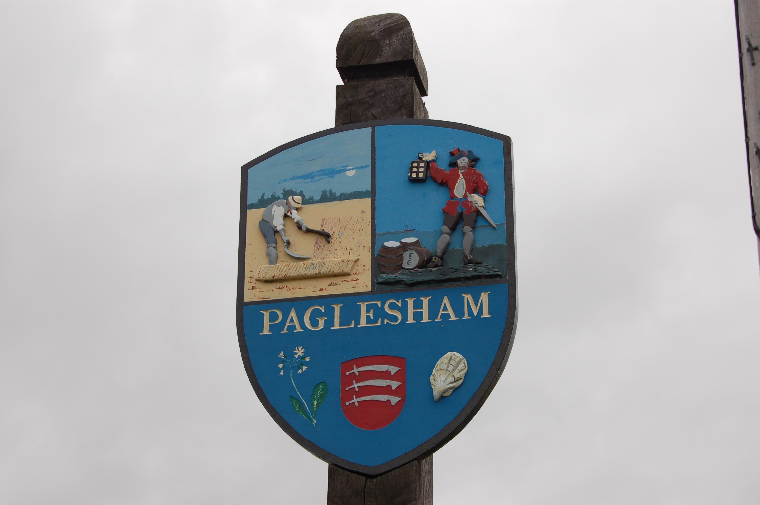

August/September 2016

PVPA (Paglesham Village Produce Association)
PVPA e-mail address – Anyone wlshing to contact the PVPA please use the following e-mail address: pvpa.paglesham@gmail.com

Past Events: -

12 June – Queens 90th Birthday Celebrations

Everyone enjoyed the ‘Street Party’ behind the Mission Hall despite the damp weather. Many thanks to the PVPA committee for putting on such a lovely village event.

Dates for your diary for 2016 :

27 August - 70th Annual Summer Show

27 November - Christmas Market and lighting of Christmas Tree.

5 December - Winter Supper.

10 December - Seniors Lunch.

Lots to look forward to and to join in with.

70th Annual Village Show 27 August 2016 –

We would be very grateful for help with the following

24 August at 5 pm – putting up the marquee – a BBQ will be provided

We still need volunteers to help with sideshows and setting up from 10 am please on the day of the Show.

Help is needed in the tea tent and if anyone can provide a cake it would be much appreciated. If you are new to the village, it is a good way of meeting people and to feel part of our community. Contact Val 258616 or Angela 258446

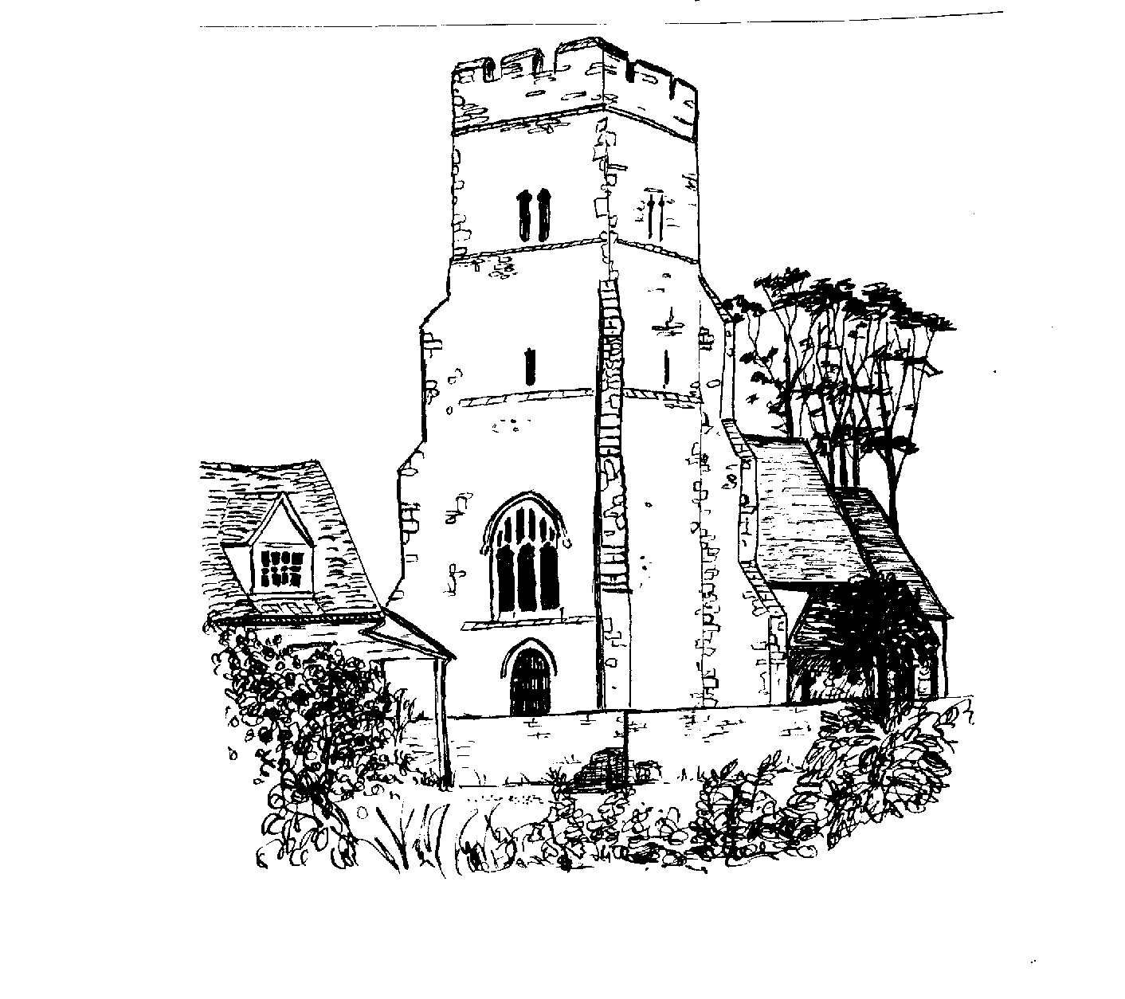

ST PETER’S CHURCH SERVICES

Tea, coffee and biscuits are served after each service.

Services:

7 August 9.30 am Morning Prayer
21 August 9.30 am Holy Communion with Rev Elizabeth Jordan
4 September 9.30 am Morning Prayer
18 September 9.30 am Harvest Service – all welcome

Refreshments are served after every service

Flower Rota:

7 August Marian Barnard
27 August Janet Thorogood
4 September Barbara Chester
18 September Harvest - all

We are currently without a resident Vicar but our services are being covered by visiting clergy.

All services at St Peter’s are displayed on the Notice Board outside the Church.

Church Wardens: Jeanette Birt – 01702 258607
Steve Nuttall – 01920 870180

10 September 2016 Art and Flower Exhibition at St Peter’s Church – refreshments available. This coincides with the Ride and Stride event organised by the Church. The Exhibition will run all week up to the Harvest Service on Sunday 18 September.

PAGLESHAM WOMEN’S INSTITUTE meet the first Wednesday of the month at 2.30 pm in the Mission Hall. New members welcome. Why not come along (free) for a taster session?

HAPPY BIRTHDAY MA’AM

The birthday of the Queen we celebrated in style
With picnics and brollies we sat to linger a while.
Decorated cakes and crowns competed for a prize,
Then the rain came down, “Oh dear!” were the sighs.
We chatted and drank, made merry in the rain
This was England after all, and then it poured again.
To those who worked hard to make this special day
A BIG vote of thanks is what we have to say.

Ann Choppin

100 Club (St Peter’s Church)

The draw took place at the Queens Street Party and congratulations to the three winners. If you would like to take part and be in with a chance, please donate £20 for the year to help keep St Peter’s Church open. Cash or cheques made payable to St Peter’s Church will be welcomed. Many thanks to everyone for their continued support.

Val Whittingham

PAGLESHAM CONGREGATIONAL CHURCH
(OPPOSITE THE OLD SCHOOL)

We welcome anyone to our meetings held on 2nd and 4th Sundays most months. We are supported by Rochford Congregational Church and our Ministers are Rev D P Saunders and Rev A P Leach.

PAGLESHAM PARISH COUNCIL

Your village councillors are:

Chairman: David Whittingham tel: 258616

Parish Clerk: Barry Summerfield tel 01702 549308
All Parish Council papers are available on
Request to the Clerk

Councillors: Val McVittie
Jeanette Wooding
Richard Bessey
Kevin Bench

Next Parish Council Meeting – 25 August 2016 at 8 pm in the Mission Hall – everyone is welcome to come along!

Have you signed up for the newly introduced Neighbourhood Watch Scheme? If not call 258616 for further details.

Pot Holes? Contact Parish Clerk on 549308
Street Lighting outage – contact the Parish Clerk as above
Worried about flooding in Paglesham? Why not sign up to Floodline – Tel – 0845 988 1188

David Whittingham
Chairman

DANCE AFTER THE SHOW!

There will be a dance after the Show on Saturday 27 August in the marquee. Tickets are £10 available from the Plough and Sail – dancing to the Beavers
VILLAGE NOTICE BOARD

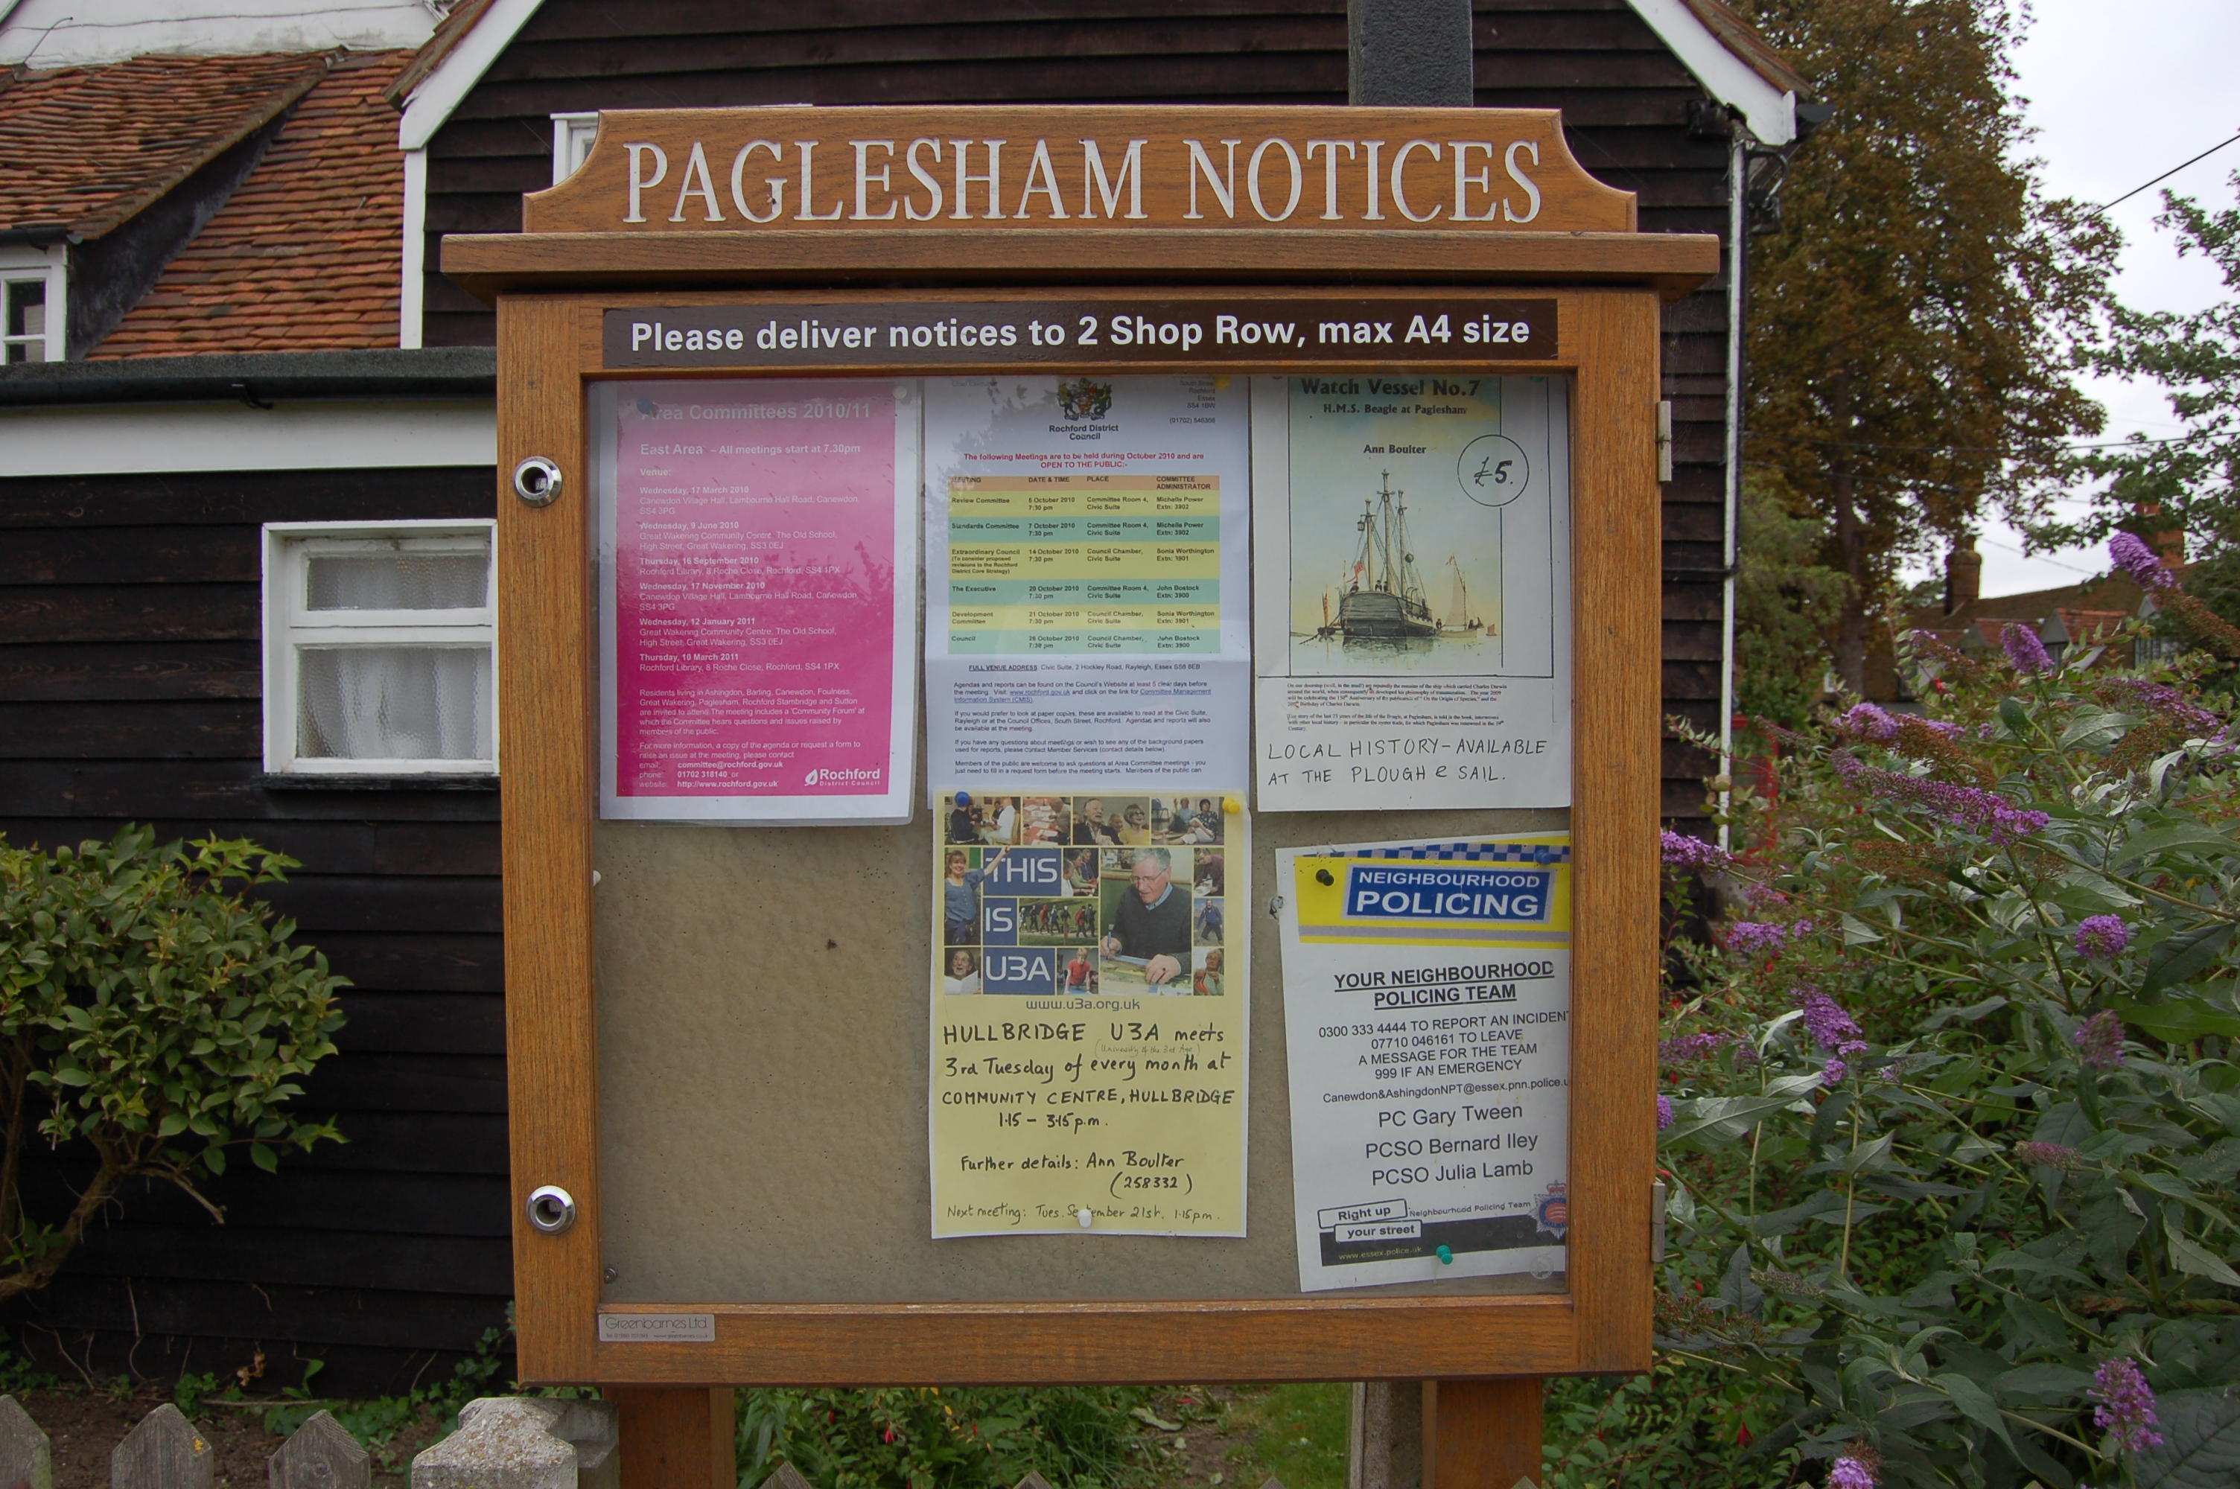

Our thoughts are with Ginny and Kevin after the sad loss of Ginny’s uncle.

Local Police – To report incidents – Neighbourhood Police Team
0300 333 4444 extension 494105

Steve - 07801461653

If anyone has any news items for the Village Notice Board – please contact us – Val 258616 or Angela 258446

