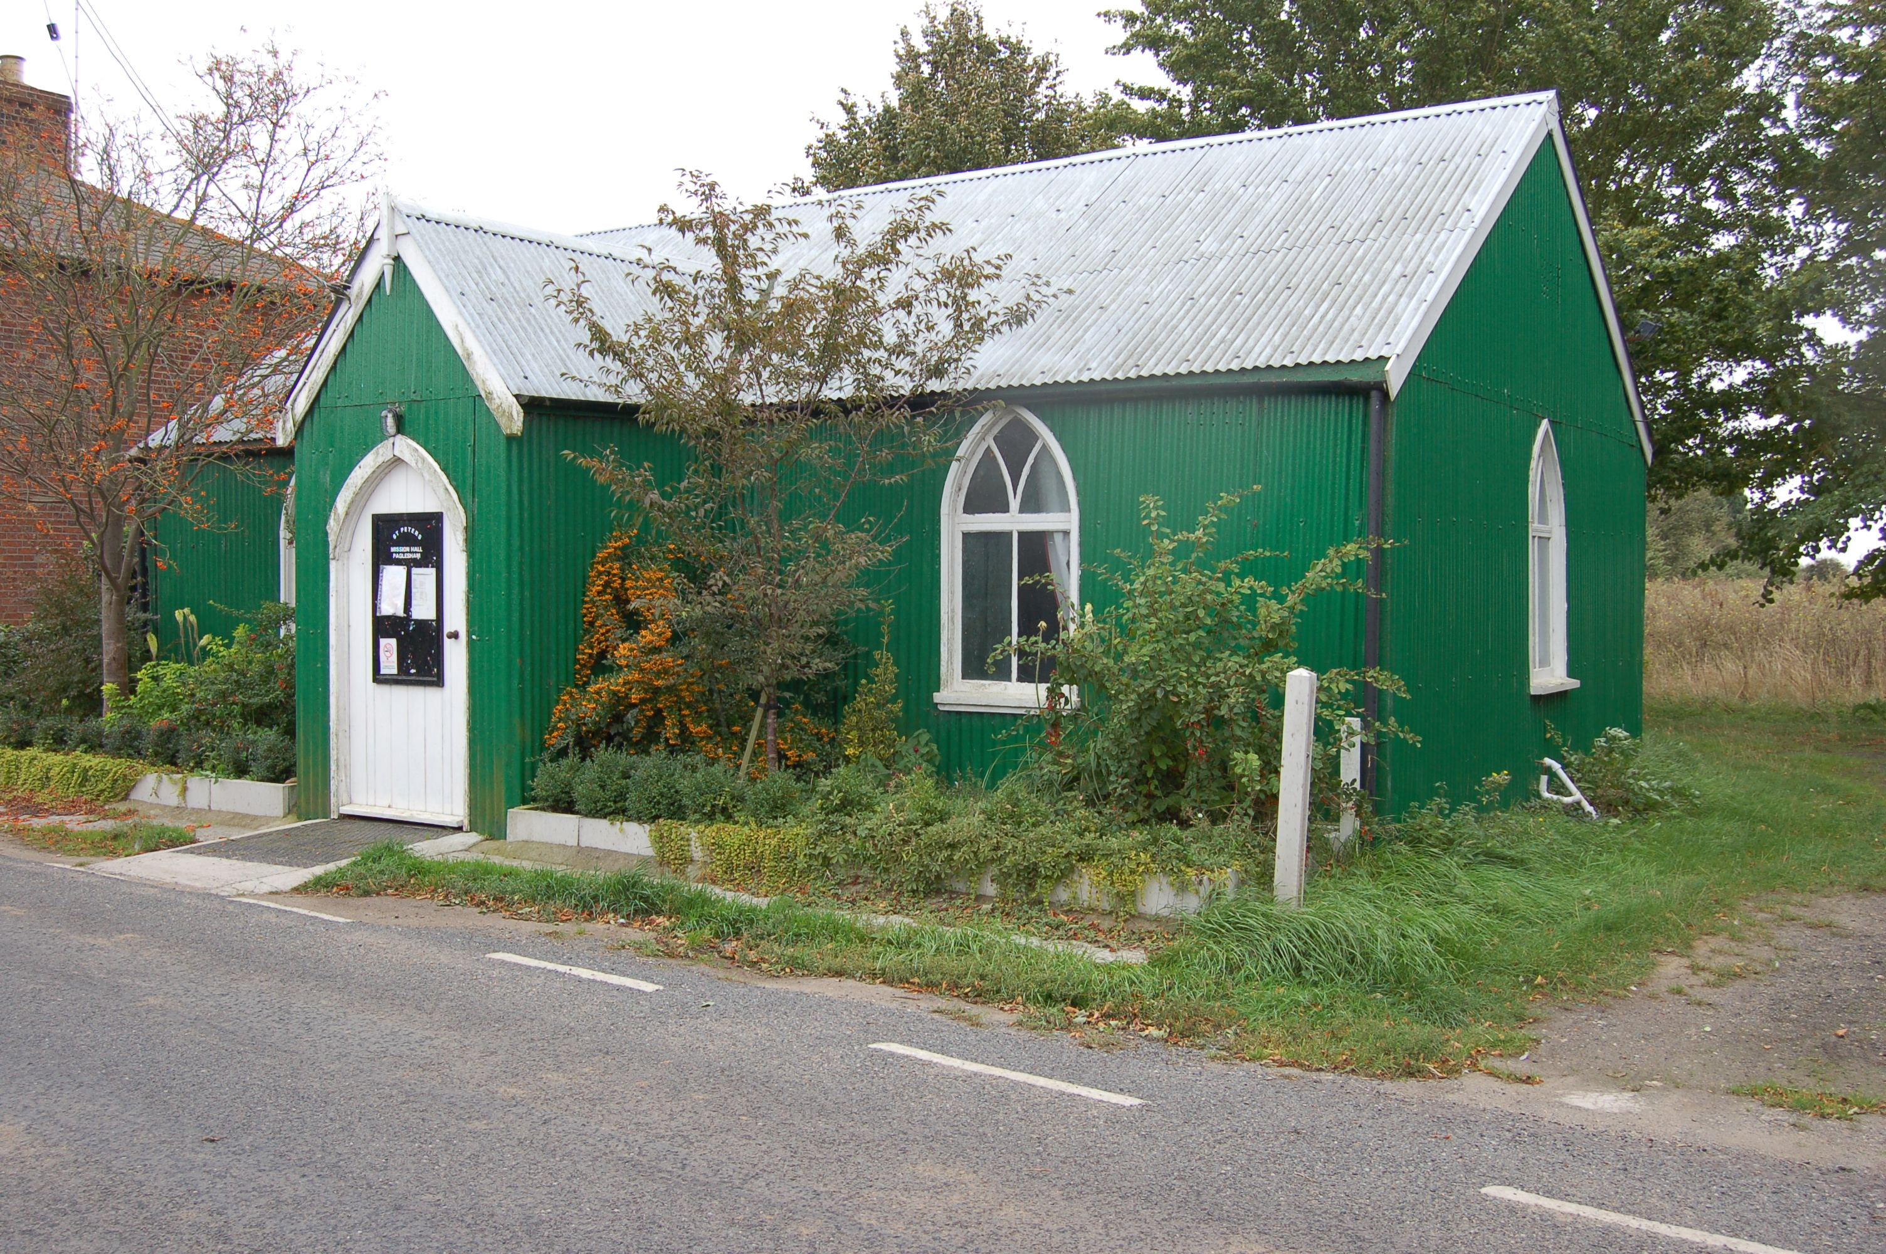

Would you like to place an advertisement in this magazine?

If you have any items for sale and you would like to advertise them in this magazine – there will be a charge of £1 per item.

If you have an item of news you feel is relevant and would like included in the magazine, please contact Val – 258616 or Angela – 258446 regarding any of the above by the 14 May ready for the June/July 2017 issue.

PAGLESHAM

VILLAGE MAGAZINE

April/May 2017

PVPA (Paglesham Village Produce Association)
PVPA e-mail address – Anyone who would like to contact the PVPA please use the following e-mail address: pvpa.paglesham@gmail.com

Spring Show – 1 April 2017

Thank you to everyone who supported the Show with their entries and their help. It was a wonderful display. If you would like to be a part of the committee to support our village, please contact the PVPA by going to the above e-mail address. New members are needed in order to carry on with all the events organised during the year.

Dates for your diary for 2017 :

8 April - Spring clean-up – 9 am start at the Mission Hall.

24 April - Spring Supper at the Punch Bowl, Church End
£17 a head 7.30 for 8 pm
Starters: Soup or mozerella & tomato salad
Main: Beef casserole or vegetarian option
Desserts: Various
Please contact Sue Winter for tickets
07780703952 or 257251

25 June - Open gardens – Please contact a member of the
committee if you are able to open your garden

26 August - 71st Annual Summer Show

9 July - Reunion of Paglesham Village School
Invitations will be going out shortly but if you
know of anyone who used to go to the school
please let them know the date and let the
Committee have details.

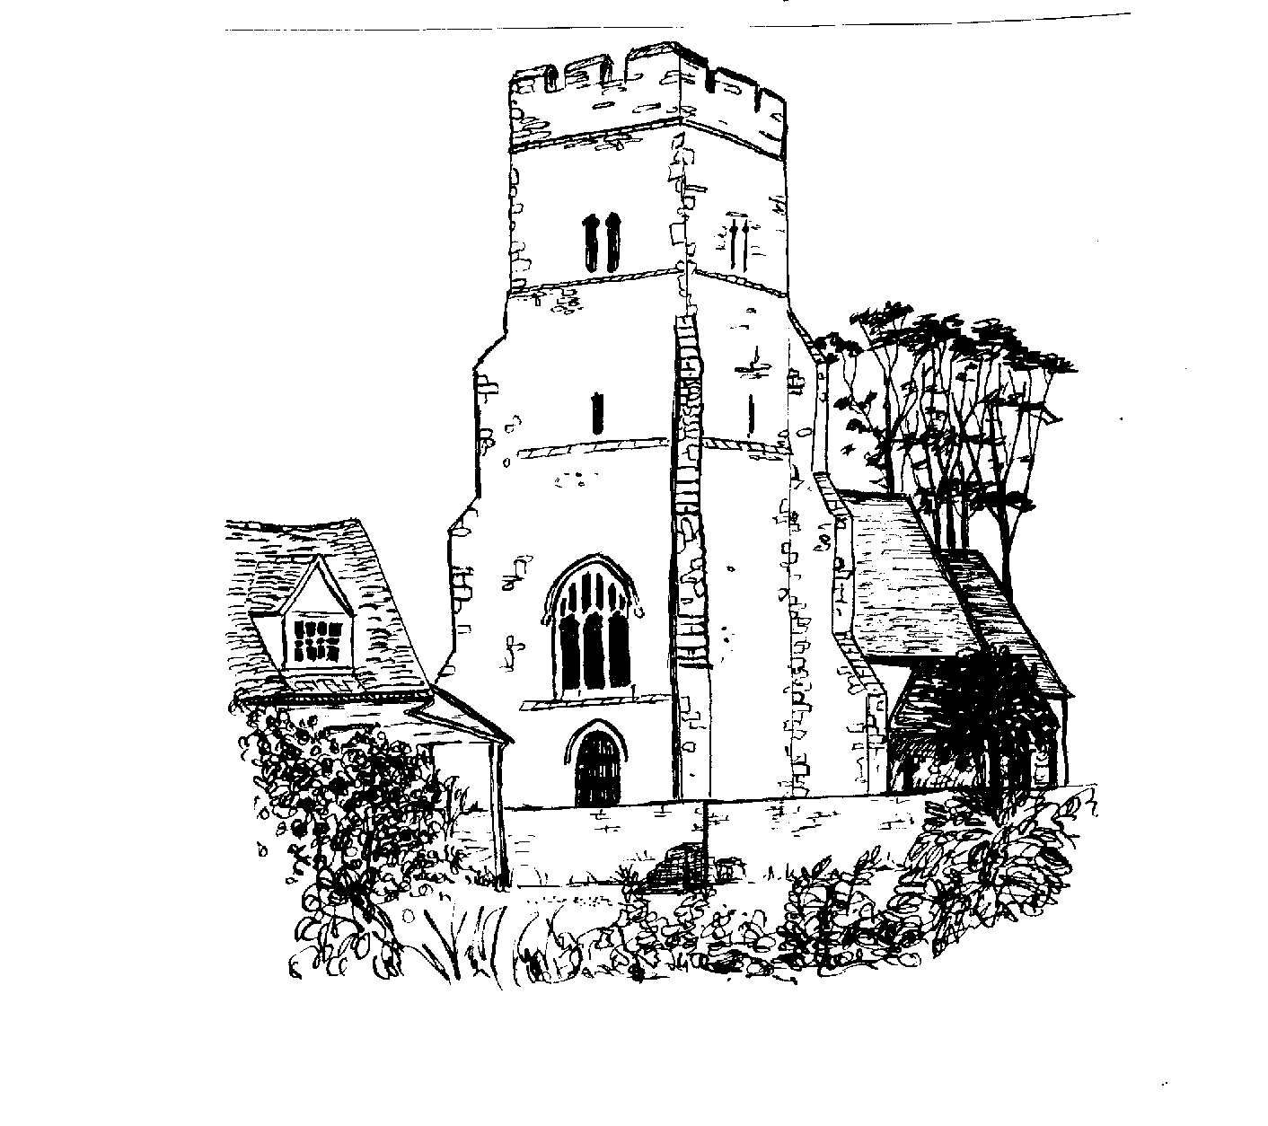

ST PETER’S CHURCH SERVICES

Tea, coffee and biscuits are served after each service.

Services:

2 April - 9.30 am Morning Prayer with Gary Edwards
EASTER SUNDAY
16 April - 9.30 am Holy Communion with Rev Elizabeth
Jordan
30 April - 10.30 am United Service at St Nicholas,
Canewdon
7 May - 9.30 am Morning Prayer with Gary Edwards
21 May - 9.30 am Holy Communion with Rev Elizabeth Jordan
Flower Rota:

16 April - Easter Flowers – all helpers – donate a lilly
30 April - Margaret Rayner
14 May - Mandy Turner

All services at St Peter’s are displayed on the Notice Board outside the Church.

Church Warden: Jeanette Birt – 01702 258607

PAGLESHAM WOMEN’S INSTITUTE meet the first Wednesday of the month at 2.30 pm in the Mission Hall. New members welcome. Why not come along (free) for a taster session?

In February we had a speaker showing us the many and varied ways of wearing a scarf; she had a very colourful collection and some good ideas. By complete contrast in March we listened avidly to Graham Bendall, a game keeper, who described his way of life on an estate and gave us a very interesting account of his experiences in mid-Essex.

Ann Choppin

PAGLESHAM CONGREGATIONAL CHURCH
(OPPOSITE THE OLD SCHOOL)

We welcome anyone to our meetings held on 2nd and 4th Sundays most months. We are supported by Rochford Congregational Church and our Ministers are Rev D P Saunders and Rev A P Leach.

Paglesham Parish Council

Your village councillors are:

Chairman: David Whittingham tel: 258616

Parish Clerk: Barry Summerfield tel 01702 549308
All Parish Council papers are available on
Request to the Clerk

Councillors: Val McVittie
Jeanette Wooding
Robbie Fance
Kevin Bench

Next Parish Council Meeting is on 11 May – at 8 pm in the Mission Hall – everyone is welcome to come along!

Pot Holes? Contact Parish Clerk on 549308
Street Lighting outage – contact the Parish Clerk as above
Worried about flooding in Paglesham? Why not sign up to Floodline – Tel – 0845 988 1188

David Whittingham
Chairman

YOUR MAGAZINE

Hopefully those wishing to access the Village Magazine have found it on the Paglesham Parish Council website.

www.pagleshamparishcouncil.co.uk

OWLS

If you have retired, a bored mum with time on your hands - or are footloose and fancy free during the day – if you would like to get together with other ladies to share conversation and interests – if you would just like to have a tea or coffee ….

Please come along to St Peter’s Church on Wednesday 19 April – 10 am – 12 pm.

Jeanette Birt would be very pleased to welcome you.

VILLAGE NOTICE BOARD

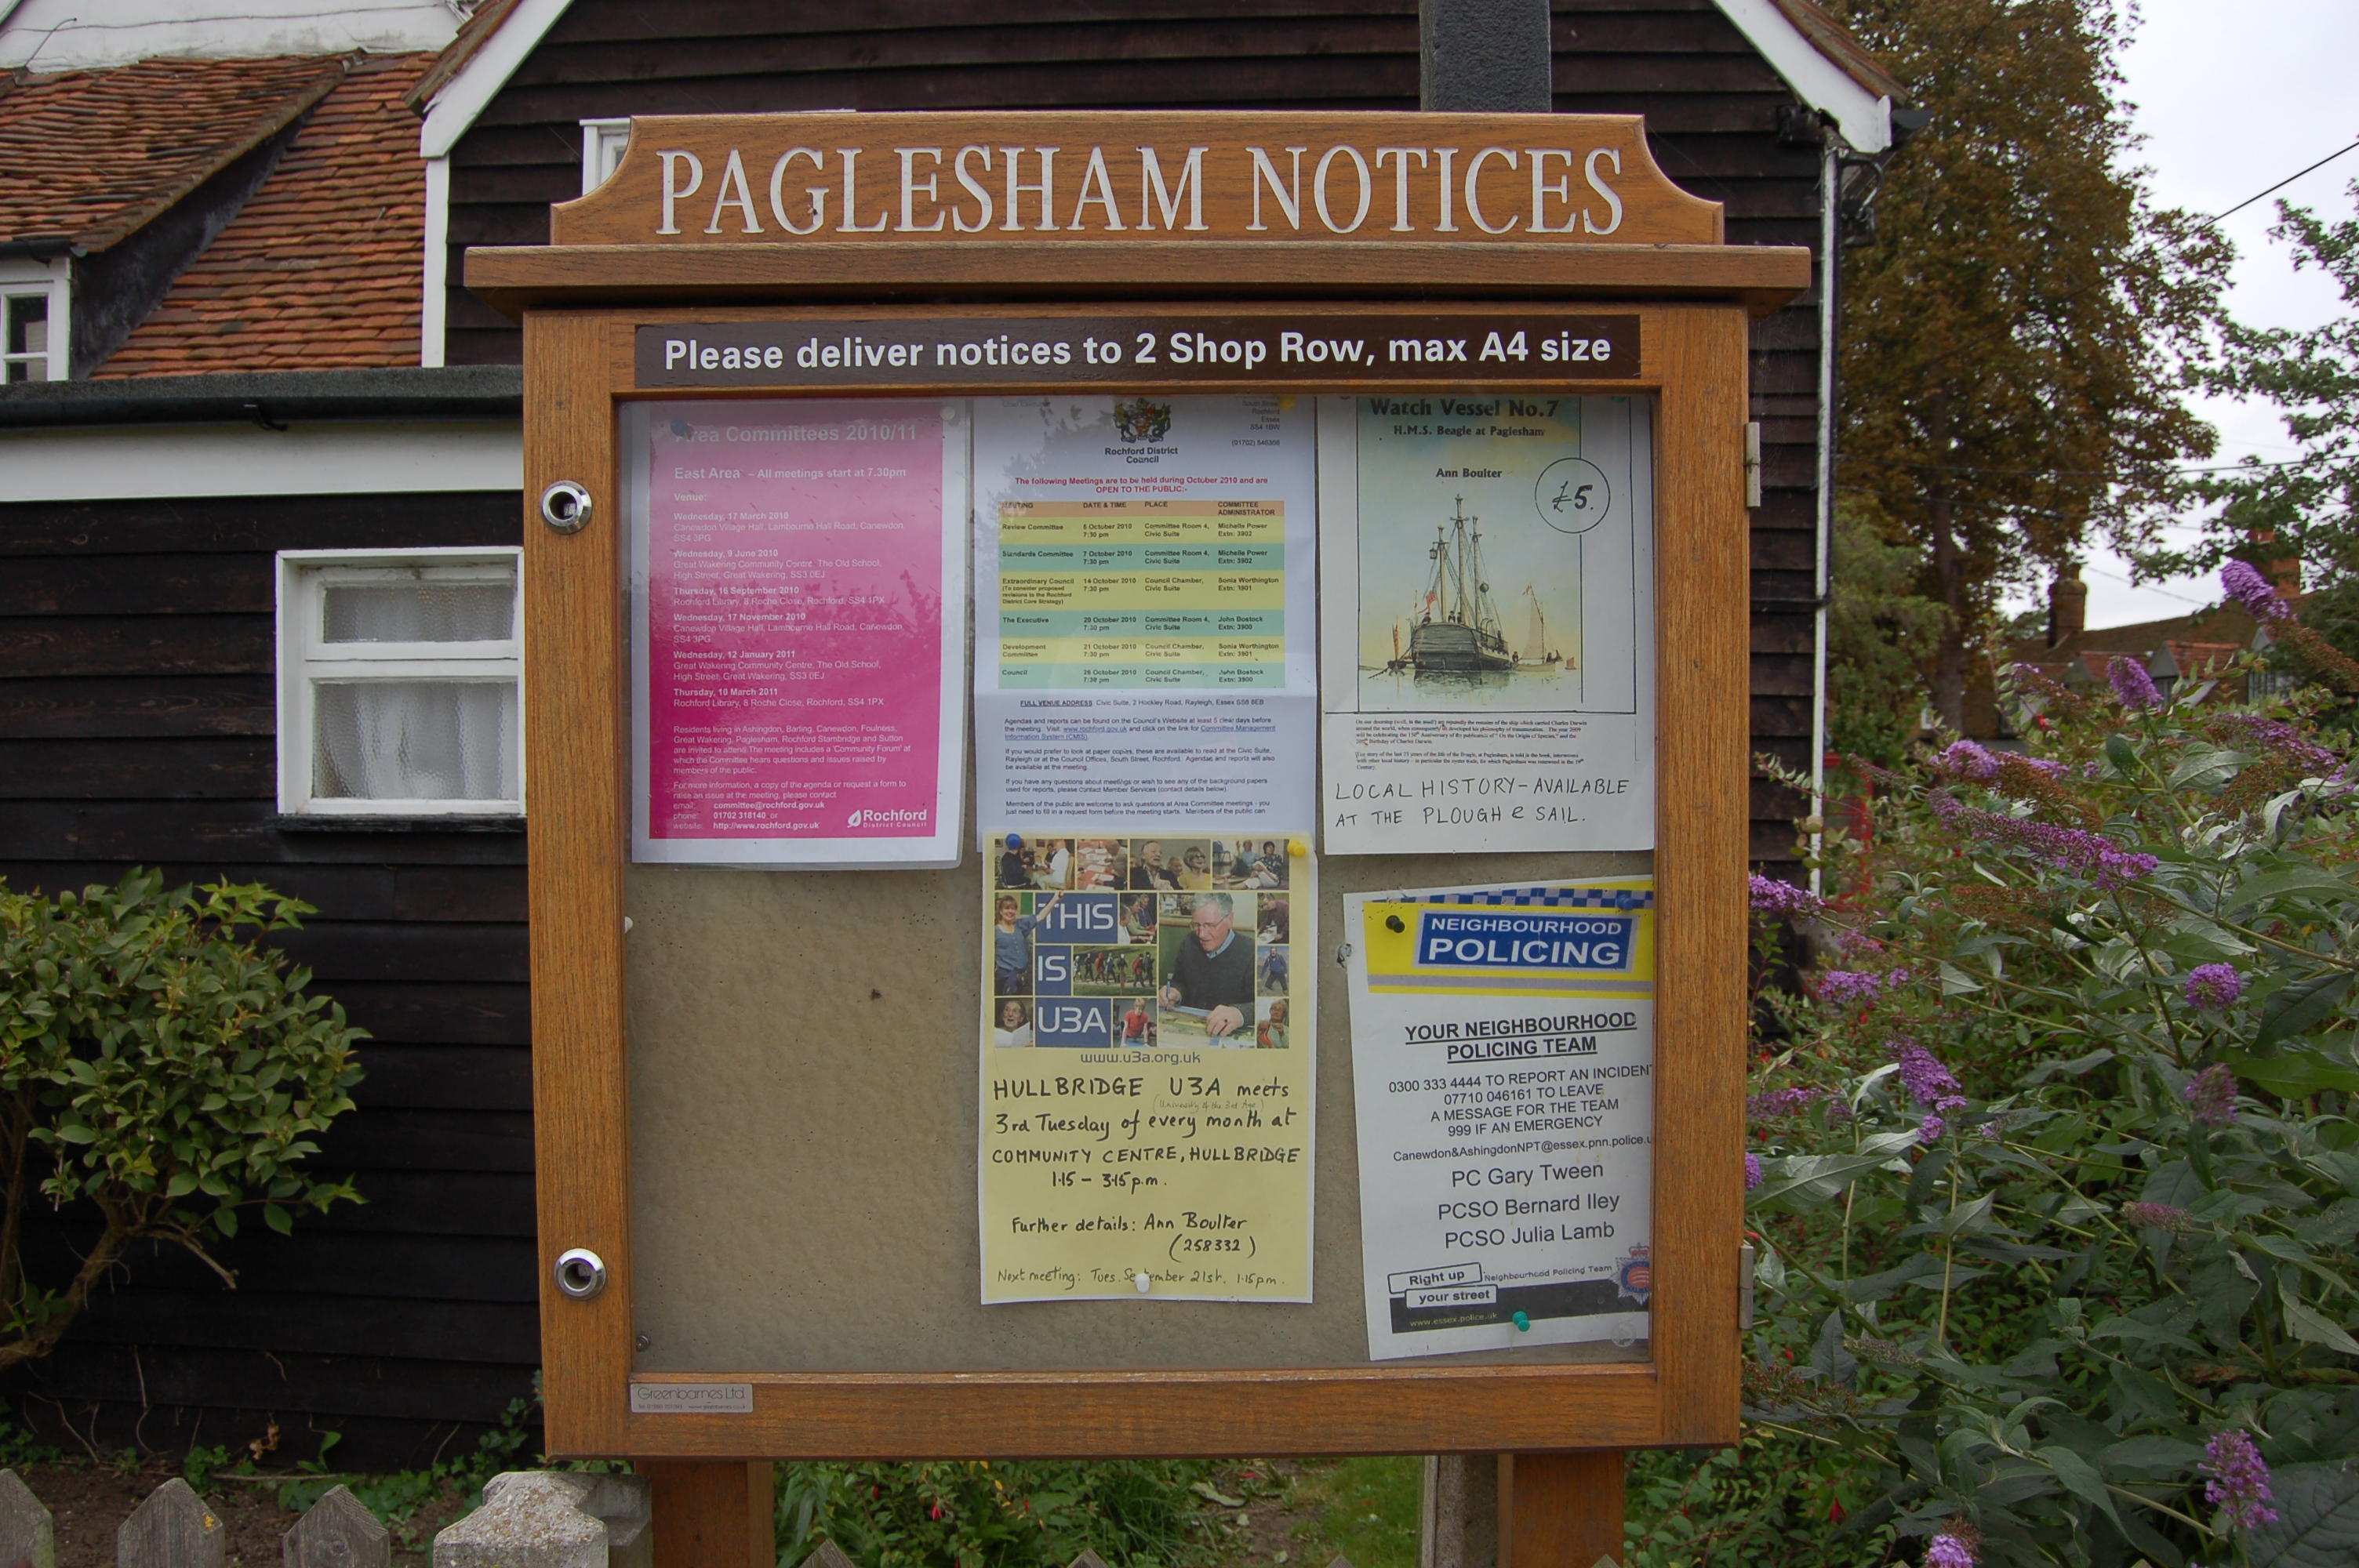

Local Police – To report incidents – Community Police Team
0300 333 4444 extension 494105

Bernie Illy or Steve Thomas 07710 046161

