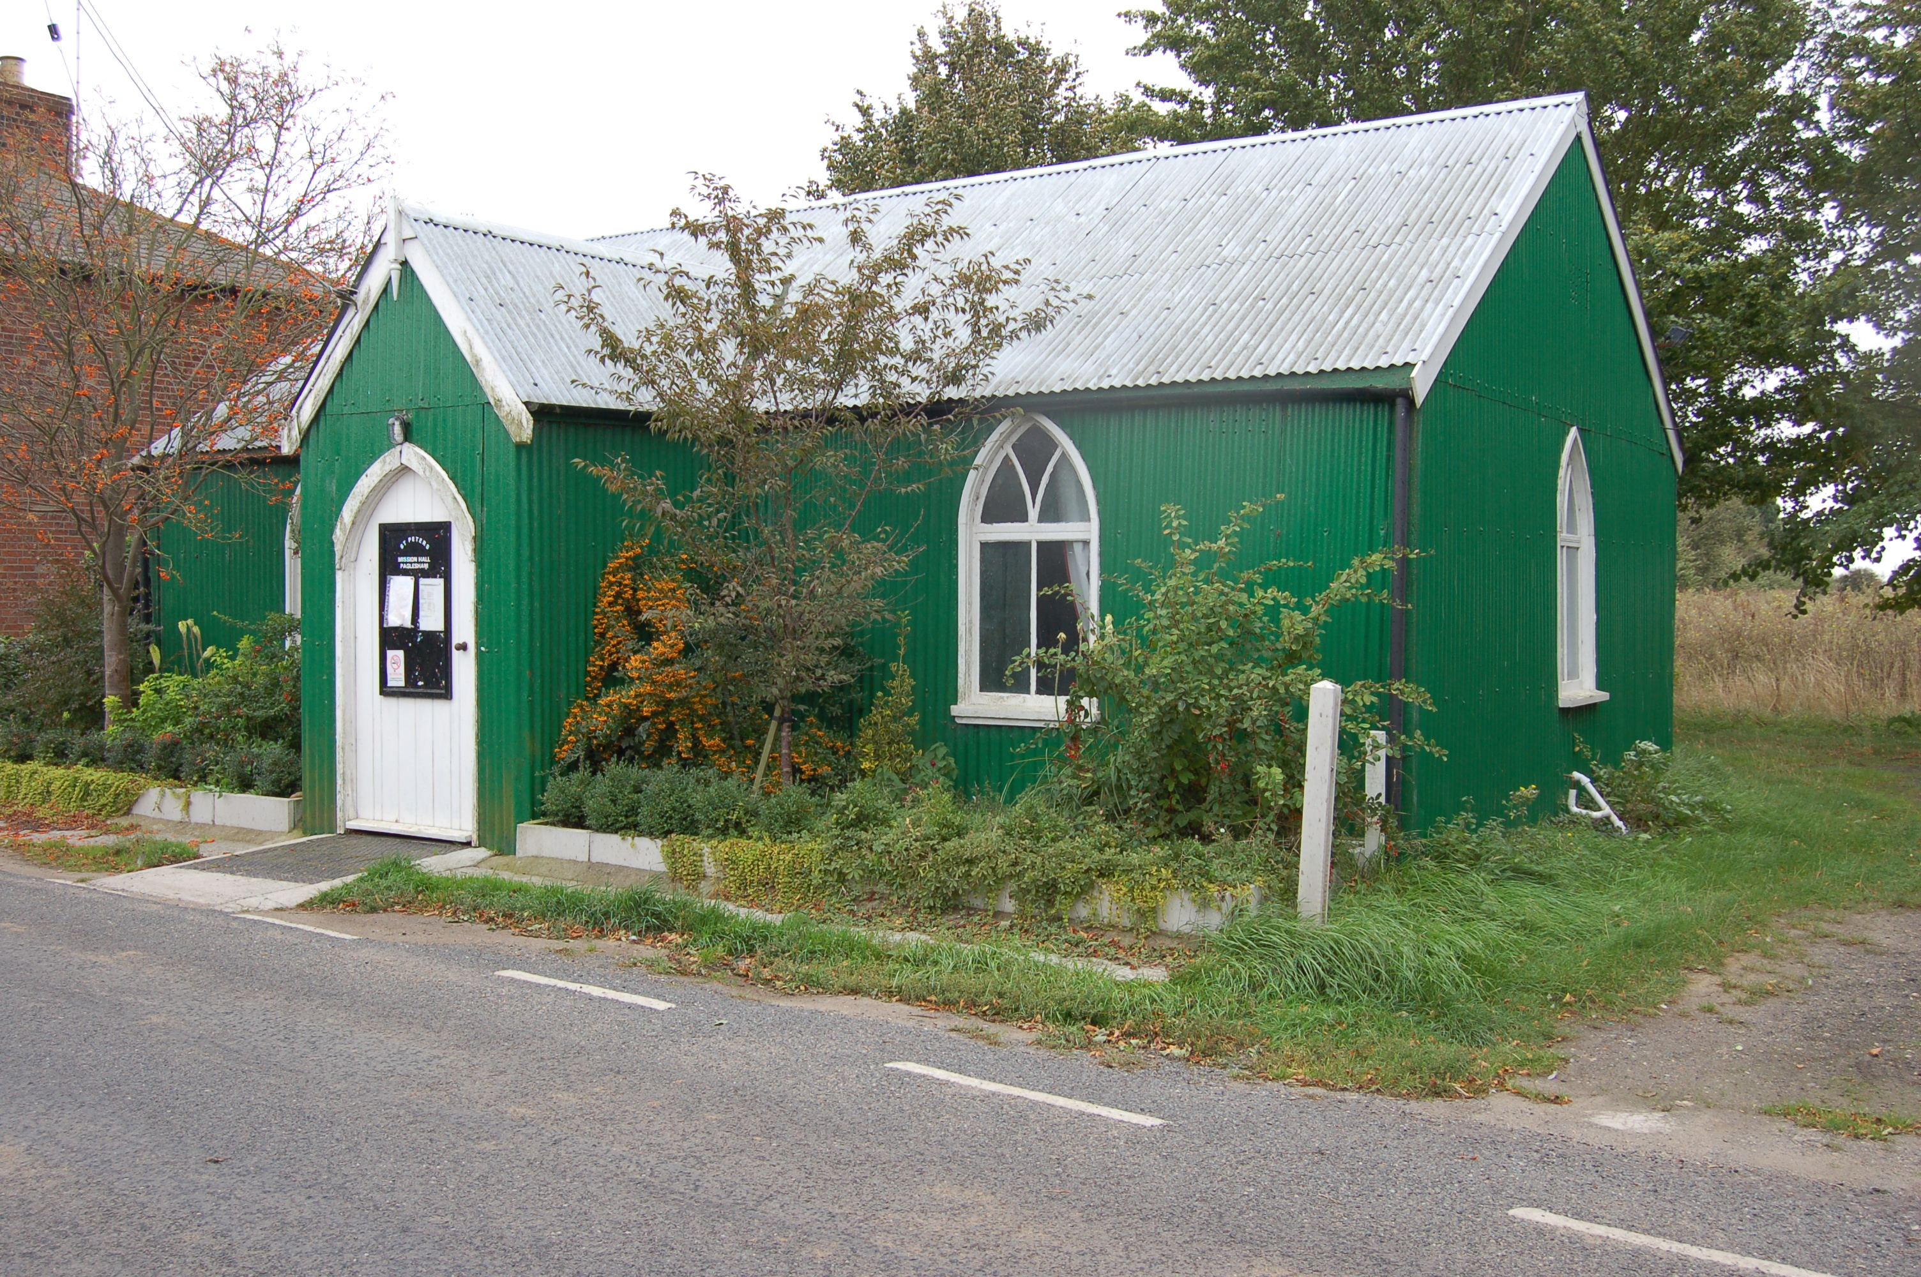

Would you like to place an advertisement in this magazine?

If you have any items for sale and you would like to advertise them in this magazine – there will be a charge of £1 per item.

If you have an item of news you feel is relevant and would like included in the magazine, please contact Val – 258616 or Angela – 258446 regarding any of the above by the 14 March ready for the April/May 2017 issue.

PAGLESHAM

VILLAGE MAGAZINE

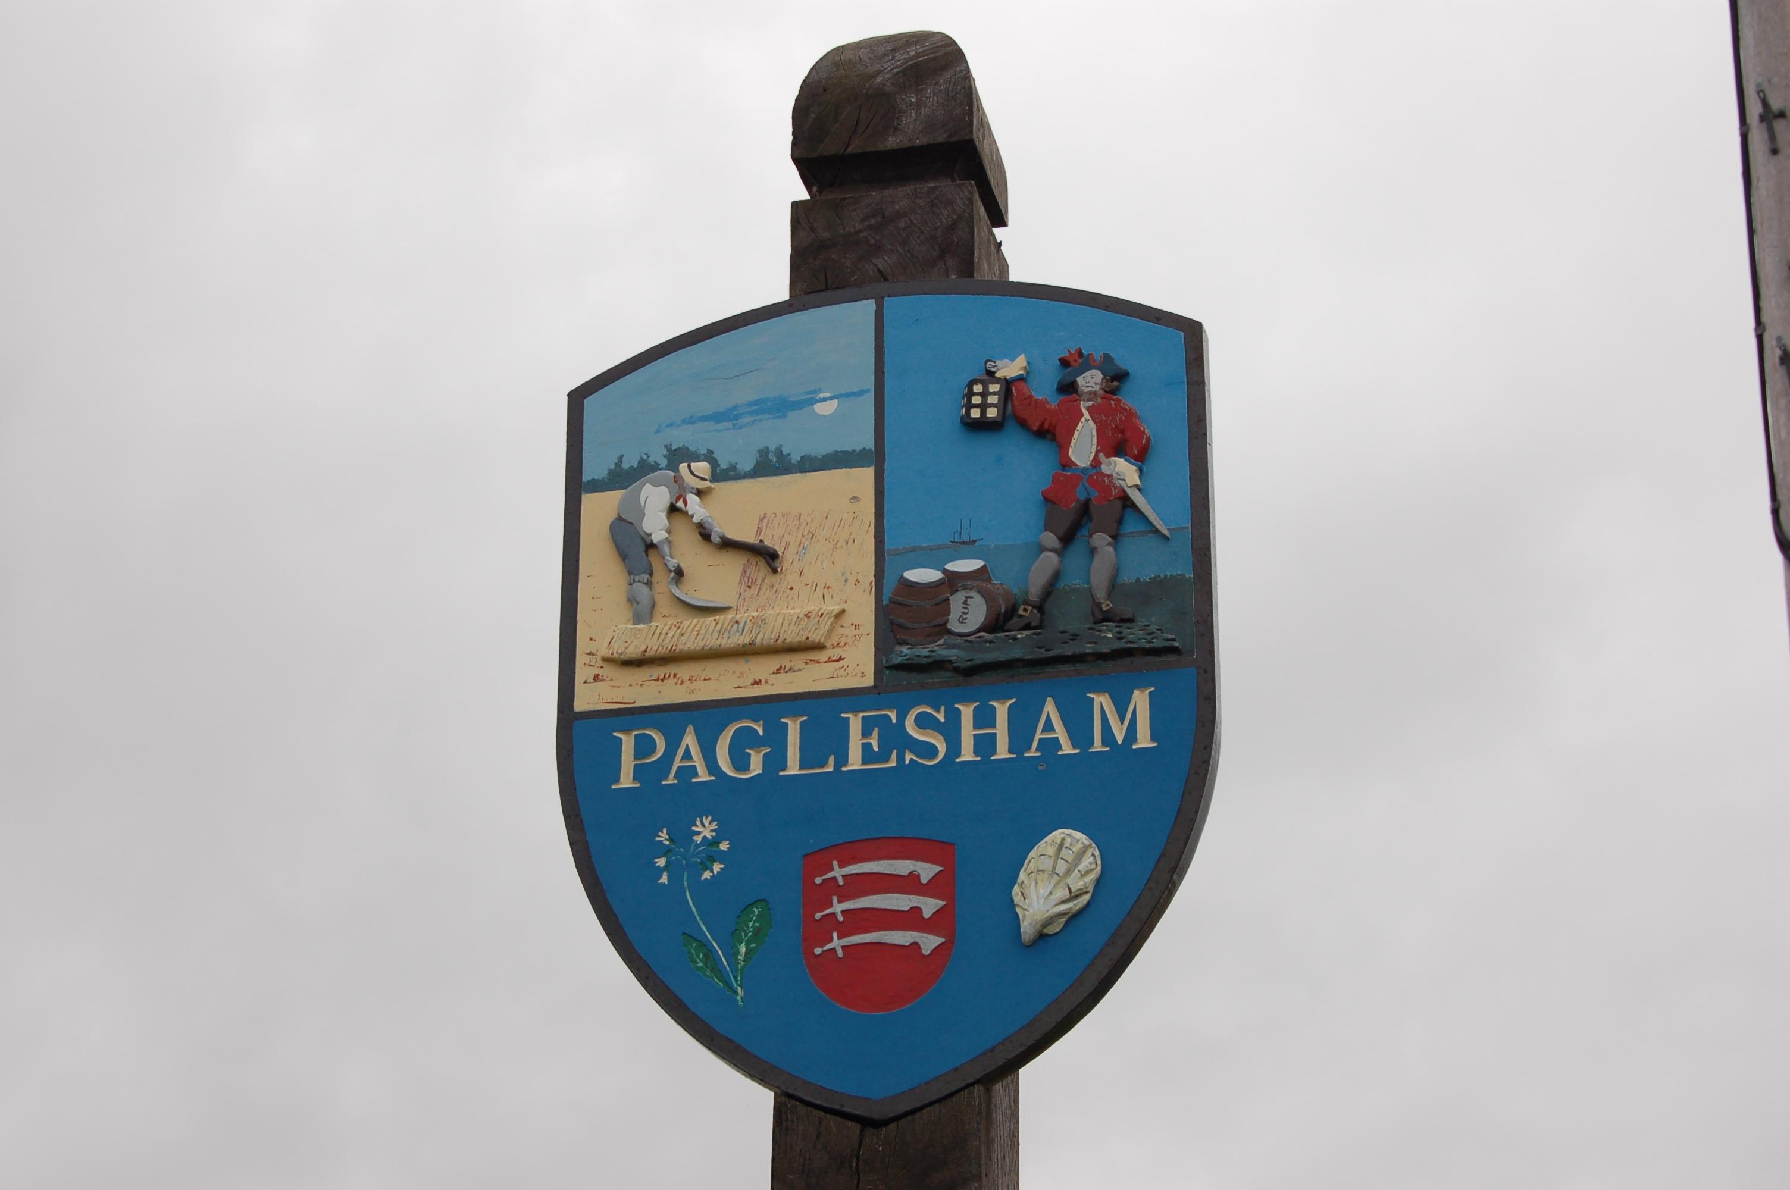

February/March 2017

PVPA (Paglesham Village Produce Association)
PVPA e-mail address – Anyone who would like to contact the PVPA please use the following e-mail address: pvpa.paglesham@gmail.com

Past Events: -

Village Christmas Tree celebration
Sunday 27 November at 4.30 pm
A very joyful occasion with the Salvation Army playing, the Christmas tree lights turned on and everyone in a festive mood. Thank you to all responsible and long may this new event continue.

5 December – Village Winter Supper – A very good evening as usual, many thanks to Mark and Lois.

10 December – Thank you to all the helpers who made this a lovely lunch for our senior members of the village.

24 December – Carol Singing in the village – We started round the Christmas Tree and continued to the usual ‘haunts’ and finished with a carol or two in the Plough and Sail. Enjoyed by all who attended.

Dates for your diary for 2017 :

23 March and 29 March – 2 sessions of flower arranging for Spring Show

1 April - Spring Show

25 June - Open gardens

26 August - 71st Annual Summer Show

9 July - Reunion of Paglesham Village School

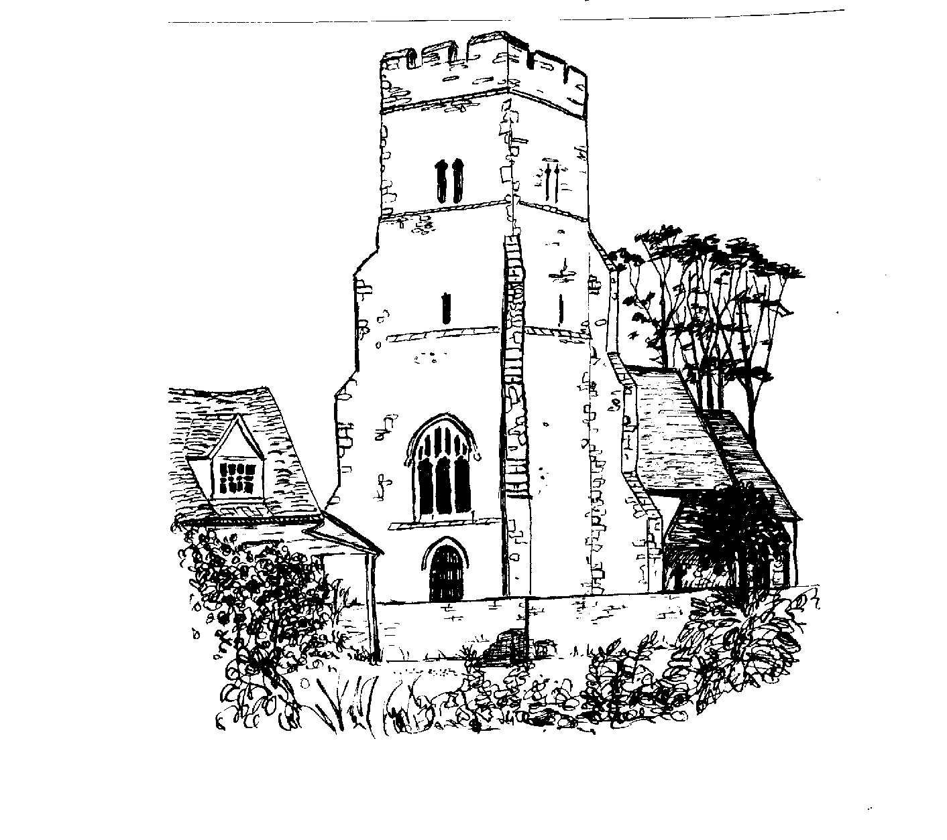

ST PETER’S CHURCH SERVICES

Tea, coffee and biscuits are served after each service.

Services:
These will be held in the Mission Hall for February.

5 February - 9.30 am Morning Prayer with Gary Edwards
19 February - 9.30 am Holy Communion with Mike Lodge

Back to St Peter’s Church

5 March - 9.30 am Morning Prayer with Gary Edwards
19 March - 9.30 am Holy Communion with Elizabeth Jordan
26 March - 11.15 am Mothering Sunday at St Nicholas
Canewdon. No service at Paglesham

Flower Rota:

5 February - Val Whittingham
19 February - Angela Puzey

No Flowers for March - Lent

All services at St Peter’s are displayed on the Notice Board outside the Church.

Church Warden: Jeanette Birt – 01702 258607

PAGLESHAM WOMEN’S INSTITUTE meet the first Wednesday of the month at 2.30 pm in the Mission Hall. New members welcome. Why not come along (free) for a taster session?

At the pre Christmas meeting singer/guitarist Tony Haywood entertained us with popular songs from the sixties onwards. In January Tracey Lane brought materials and plain cards for us to create our own personal works of art, and by the end of the afternoon we were surprised at how skilled we could be! It was a productive and enjoyable session.

Ann Choppin

100 Club (St Peter’s Church)

Congratulations to the winners of the December draw who have been informed and their winnings passed to them. It is not too late to join in for the June draw.

Val Whittingham

PAGLESHAM CONGREGATIONAL CHURCH
(OPPOSITE THE OLD SCHOOL)

We welcome anyone to our meetings held on 2nd and 4th Sundays most months. We are supported by Rochford Congregational Church and our Ministers are Rev D P Saunders and Rev A P Leach.

Paglesham Parish Council

Your village councillors are:

Chairman: David Whittingham tel: 258616

Parish Clerk: Barry Summerfield tel 01702 549308
All Parish Council papers are available on
Request to the Clerk

Councillors: Val McVittie
Jeanette Wooding
Robbie Fance
Kevin Bench

Next Parish Council Meeting ?– at 8 pm in the Mission Hall – everyone is welcome to come along!

Pot Holes? Contact Parish Clerk on 549308
Street Lighting outage – contact the Parish Clerk as above
Worried about flooding in Paglesham? Why not sign up to Floodline – Tel – 0845 988 1188

David Whittingham
Chairman

YOUR MAGAZINE

As explained in the last edition of the magazine we are now putting this on the Parish council website. I asked if anyone needed a printed version - if they did not have access to a computer – only one person came back to us so I am assuming all others able to access from the website!

THE DAFFODILS
(William Wordsworth 1770 – 1850)

I wander’d lonely as a cloud
That floats on high o’er vales and hills,
When all at once I saw a crowd,
A host of golden daffodils,
Beside the lake, beneath the trees
Fluttering and dancing in the breeze.

Continuous as the stars that shine
And twinkle on the milky way,
They stretch’d in never-ending line
Along the margin of a bay;
Ten thousand saw I at a glance
Tossing their heads
In sprightly dance.

The waves beside them danced, but they
Out-did the sparkling waves in glee –
A Poet could not but be gay
In such a jocund company!
I gazed – and gazed – but little thought
What wealth the show to me had brought.

For oft, when on my couch I lie
In vacant or in pensive mood,
They flash upon that inward eye
Which is the bliss of solitude;
And then my heart with pleasure fills
And dances with the daffodils.

(a scenario to look forward to!)

VILLAGE NOTICE BOARD

Local Police – To report incidents – Neighbourhood Police Team
0300 333 4444 extension 494105

Steve - 07801461653

